© 2021 National Disease Registration Service (NDRS). All Rights Reserved

Ovarian Cancer Audit Feasibility Pilot
Short-term mortality in ovarian, fallopian tube and primary peritoneal carcinomas across England
© 2021 National Disease Registration Service (NDRS). All Rights Reserved

About the NDRS
The National Disease Registration Service (NDRS) is part of NHS Digital (NHSD). Its purpose is to collect high-quality, timely data on cancer, rare diseases and congenital anomalies to monitor changes in the health of the population.

The NDRS includes:
- the National Cancer Registration and Analysis Service (NCRAS) and
- the National Congenital Anomaly and Rare Disease Registration Service (NCARDRS)

Healthcare professionals, researchers and policy makers use data to better understand population health and disease. The data is provided by patients and collected by the NHS as part of their care and support. The NDRS uses the data to help:
- understand cancer, rare diseases, and congenital anomalies
- improve diagnosis
- plan NHS services
- improve treatment
- evaluate policy
- improve genetic counselling

National Disease Registration Service
NHS Digital (NHSD)
The Leeds Government Hub
7&8 Wellington Place
Leeds
LS1 4AP

For queries relating to this document, please contact:
NDRSenquiries@nhs.net

Improving lives with data and technology – NHS Digital support NHS staff at work, help people get the best care, and use the nation's health data to drive research and transform services.
Table of Contents
About the NDRS 1
Ovarian Cancer Audit Feasibility Pilot Steering Group 4
Executive summary 5
Background 7
Methods 8
Mortality distribution in ovarian cancer patients 10
Mortality variation by tumour site 11
Mortality variation by tumour morphology 11
Mortality variation by basis of diagnosis 12
Mortality variation by stage at diagnosis 13
Mortality variation by route to diagnosis 14
Mortality variation by patient age at diagnosis 15
Mortality variation by deprivation 16
Mortality variation by ethnicity 17
Mortality variation by comorbidity 18
Mortality variation by WHO performance status 19
Mortality variation by treatment 20
Mortality variation by cancer centre 21
Mortality variation by GP to population ratio 23
Adjusted mortality rates 25
Mortality by Cancer Alliance 28
Mortality by Alliance within 2 months from diagnosis 28
Mortality by Alliance within 2 to 6 months from diagnosis 29
Mortality by Alliance within 6 to 12 months from diagnosis 30
Conclusion 32
Limitations 34
Appendix 1: Methodology 36
Cohort definition 36
Defining short-term mortality groups 36
Defining patient demographics and tumour characteristics 37
Statistical analysis 40
Appendix 2: Cohort demographics 43
Appendix 3: Factors associated with ovarian cancer patient mortality between 0 and 2 months following a diagnosis 52
Appendix 4: Factors associated with ovarian cancer patient mortality between 2 and 6 months following a diagnosis 54
Appendix 5: Factors associated with ovarian cancer patient mortality between 6 and 12 months following a diagnosis 56
Appendix 6: Ovarian cancer patient mortality by Cancer Alliance between 0 and 2 months following a diagnosis 58
Appendix 7: Ovarian cancer patient mortality by Cancer Alliance between 2 and 6 months following a diagnosis 59
Appendix 8: Ovarian cancer patient mortality by Cancer Alliance between 6 and 12 months following a diagnosis 60
Appendix 9: Sensitivity analysis 61
Appendix 10: Route to diagnosis by Cancer Alliance in patients with short-term mortality 64
Appendix 11: Comorbidity conditions 65
Appendix 12: List of trusts containing cancer centres in 2021 66
Appendix 13: Glossary 68
Appendix 14: Useful links 71
References 73

Ovarian Cancer Audit Feasibility Pilot Steering Group
Chair
Mr Andy Nordin, Consultant Gynaecological Oncologist, East Kent Hospitals; Clinical Advisor, National Cancer Registration and Analysis Service (NCRAS)
British Gynaecological Cancer Society (BGCS)
Professor Sudha Sundar, President and Consultant Gynaecological Oncologist, Pan Birmingham Gynaecological Cancer Centre, Professor of Gynaecological Cancer, University of Birmingham
Mr Jo Nieto, Consultant Gynaecological Oncologist, Norfolk and Norwich University Hospitals
Ovarian Cancer Action
Cary Wakefield, Chief Executive
Marie-Claire Platt, Head of Research and Public Affairs
Target Ovarian Cancer
Annwen Jones OBE, Chief Executive
Rebecca Rennison, Policy Consultant
National Cancer Registration and Analysis Service (NCRAS)
Charlotte Eversfield, Senior Cancer Intelligence Analyst, NHS Digital
Dr Charlie Turner, Senior Cancer Data Analyst, NHS Digital
Dr Craig Knott, Senior Data Analyst, Health Data Insight CIC and NHS Digital
Lizz Paley, Partnerships Analytical Lead, NHS Digital

Data for this report is based on patient and tumour-level information collected by the NHS, as part of the care and support of cancer patients. The data is collated, maintained and quality assured by the National Cancer Registration and Analysis Service, which is part of NHS Digital.

Executive summary
Ovarian cancer is the leading cause of cancer gynaecological death for women in the UK. Studies have found that a disproportionately high percentage of ovarian cancer patients die within the first year following their diagnosis. This report investigates factors associated with mortality in the first year after diagnosis of ovary, fallopian tube and primary peritoneal carcinomas and examines to what extent geographical variation occurs at a Cancer Alliance level.
Data from the National Cancer Registration dataset were used to identify women diagnosed with ovary, fallopian tube and primary peritoneal carcinomas in England between 2013 and 2018. To examine how mortality rates changed over the first year after diagnosis, patients were assigned into 4 groups: patients who died within 0 to 2 months, 2 to 6 months, 6 to 12 months, or patients who did not die within 12 months following diagnosis. Crude mortality rates were calculated to examine the distribution of patient demographics and tumour characteristics across these short-term mortality groups. Factors investigated include tumour site, tumour morphology, basis of diagnosis, stage at diagnosis, route to diagnosis, age at diagnosis, deprivation quintile, ethnicity, comorbidity, performance status, treatment, whether the trust at diagnosis housed a specialist gynaecological cancer centre and GP to population ratio. Factors were assessed for statistically significant differences in mortality via chi-squared tests. Mixed effects logistic regression models were fitted to estimate the association of statistically significant factors with short-term mortality in ovarian cancer patients. To examine geographical variation, crude and case-mix adjusted mortality rates for each Cancer Alliance were calculated.
Results from these analyses show that the short-term mortality rate for ovarian, tubal and primary peritoneal cancer patients remains high. 14% died within 2 months of diagnosis, and 30% died within the first year. This compares to an analysis by the NCIN of 2006-2008 cases, published in 2013, which showed a 15% 2 month and 31% 12 month mortality rate. However, the 2013 analysis included cases of borderline tumours with an excellent long term prognosis and excluded primary peritoneal cancer which has a relatively high short-term mortality rate, suggesting a modest overall improvement in short-term mortality rates from ovarian cancer in England over the last decade.
Mixed effect logistic regression models show that mortality rates were impacted by a number of factors. The greatest variation in patient mortality across different patient demographics and tumour characteristics was seen for women who died within 2 months following their diagnosis. Mortality rates were significantly higher for older women, women who were diagnosed at a later or unknown stage of disease, had an unknown morphology, were diagnosed following an emergency presentation or non-urgent route, women who had a greater burden of comorbidities and women who had a more deprived socioeconomic status. There was also a strong trend observed of higher short-term mortality rates in patients diagnosed in a trust that did not house a specialist gynaecological cancer centre compared to trusts that did. This trend remained significant for patients that died within 2 to 6 months of diagnosis. Crude and case-mix adjusted results indicated that some variation in short-term mortality may exist at a Cancer Alliance level, but that much of this variation is likely due to different patient case-mix or that while variation still exists at a more local level, this has evened out by the time data is analysed at Alliance level.
The results from this report suggest a need for earlier diagnosis via increasing symptom awareness and timely general practitioner referral, for women of all backgrounds, to aid in reducing ovarian cancer mortality within the first year of diagnosis.

Background
The Ovarian Cancer Audit Feasibility Pilot (OCAFP) is a collaboration between the gynaecological oncology clinical community, the charity sector and NHS Digital. It aims to undertake meaningful analyses of routinely collected data for the purpose of improving treatment and outcomes for women diagnosed with ovarian cancer in England. The OCAFP is jointly funded by the British Gynaecological Cancer Society, Target Ovarian Cancer and Ovarian Cancer Action, and is being delivered by analysts at the National Disease Registration Service (NDRS), part of NHS Digital. The pilot originally ran for 2 years from 2019 and has been extended for an additional year. The pilot will publish a range of data outputs on ovarian cancer, including a final report on the audit and its findings, bringing all the analysis into one place. The outputs can be found on the project webpage.
The first publication from the OCAFP was the Disease Profile in England report, which describes incidence, mortality, stage and survival for ovary, fallopian tube and primary peritoneal carcinomas diagnosed in England.¹ This report found that 32% of ovarian cancer patients do not survive 1-year after their diagnosis and that there was variation in ovarian cancer patient survival across England, with age-standardised 1-year net survival for the 19 Cancer Alliances varying between 62.9% and 75.2%.
Previous work by The National Cancer Intelligence Network (NCIN) investigated short-term mortality of ovarian cancer patients diagnosed in 2006 to 2008 and 2008 to 2010.^{2,3} The analysis covering 2006 to 2008 found that 31% of ovarian cancer patients died within 1 year following diagnosis, and that almost half (49%) of these patients died within the first 2 months following their diagnosis.² This cohort only included patients diagnosed with ICD10 C56 and C57 (and includes borderline tumours). Barclay et al, (2016) extended this analysis to include ICD10 C48 and excluded borderline tumours to investigate factors associated with mortality via a multivariate Poisson model.³ They found that 36% of ovarian cancer patients died within 1 year following diagnosis and of these 32% died within the first month following diagnosis. They also found that many factors impacted ovarian cancer patient mortality, finding considerable differences by age, route to diagnosis, stage, morphology, basis of diagnosis and treatment, with smaller differences by comorbidity and deprivation.³
This report builds on these analyses, to explore additional factors associated with short-term mortality in patients diagnosed with ovary, fallopian tube and primary peritoneal carcinomas in England and covers more recent years. This report has also been extended to include patients diagnosed with neoplasms of uncertain or unknown behaviour of female genital organs (ICD-10 D39.1) and a geographical breakdown to investigate to what extent variation in short-term mortality occurs between Cancer Alliances.

Methods
There were 40,521 women diagnosed with ovary, fallopian tube and primary peritoneal carcinomas, hereinafter referred to as ‘ovarian cancer’, in England between 2013 and 2018 extracted from the National Cancer Registration dataset. Due to data quality reasons, 128 cases were excluded from the analysis (missing NHS numbers, n=32; embarked patients (patient stopped being registered in England and Wales for primary care on a specified date, such as in the case of moving outside of England), missing vital status date or known issue with the vital status, n=96). 187 cases were also excluded as their cancer registrations had an unknown basis of diagnosis. There were also 2 cases with a death certificate only record which were removed from the cohort. Cases with borderline malignancies (n=6,639) were excluded from the cohort as these cases do not exhibit short-term mortality, with a 12 month net survival rate of almost 100%.¹ The first ovarian cancer diagnosis in the study period for each patient was selected (excluding borderlines), leaving a final cohort of 33,442 ovarian cancer patients in the analysis.
The first section of this report describes the distribution of mortality by patient demographics and tumour characteristics. Variables investigated include: tumour site, tumour morphology, basis of diagnosis, stage at diagnosis, route to diagnosis, age at diagnosis, deprivation quintile, ethnicity, comorbidity, performance status, treatment, whether the trust at diagnosis housed a specialist gynaecological cancer centre and General Practitioner (GP) to population ratio. To examine how mortality rates changed over the first year after diagnosis, patients were assigned into 4 groups:
- Patients who died within the first 2 months after diagnosis, defined as 0-60 days (n=4,548)
- Patients who survived more than 2 months after diagnosis but died within 6 months of diagnosis, defined as 61-180 days (n=2,815)
- Patients who survived more than 6 months after diagnosis but died within the first year of diagnosis, defined as 181-365 days (n=2,756)
- Patients who survived longer than one year following diagnosis, defined as over 365 days (n=23,323)
Analysis considered crude mortality rates, defined as the percentage of ovarian cancer patients who died within 2 months, 2 to 6 or 6 to 12 months following their diagnosis, or survived longer than 1 year, divided by the number of patients included in the cohort. This is presented in figures 3-16, with descriptive data available in Appendix 2, Table 1. Figures 3-16 also present the percentage of patients diagnosed in the total cohort at the top of each stacked bar.
The second section of this report investigates the association of factors with short-term mortality via unadjusted (crude) and adjusted mortality rates. To further examine mortality in each of the 3 short-term mortality intervals, the data were split into 3 cohorts each excluding patients that had died prior to the short-term mortality interval being investigated:
- To investigate patients who died within the first 2 months after diagnosis the total cohort was used (n=33,442)
- Patients who were alive at day 61 were included in the cohort to investigate patients who died within 2 to 6 months (n=28,894)
- Patients who were alive at day 181 were included in the cohort to investigate patients who died within 6 to 12 months following diagnosis (n=26,079)
Chi-squared tests were performed to ascertain whether there was a statistically significant difference in mortality rates for each of the short-term mortality time periods by patient demographics and tumour characteristics (Appendix 2, Table 2).
Unadjusted mortality rates were calculated as the percentage of patients that died within the short-term mortality interval divided by the number of patients in each cohort. Rates were presented with 95% confidence intervals calculated using the Wilson score method (Appendices 3-5).⁴ Two mixed effects logistic regression models were fitted for each short-term mortality group to allow comparisons according to differing levels of covariate adjustment. The first model (minimally adjusted model) adjusted for age at diagnosis, tumour morphology, stage at diagnosis, deprivation quintile, ethnicity and comorbidity. To account for additional hospital level variation, trust at diagnosis was also included as a random effect. For diagnosis to 2 months only, basis of diagnosis was also included to adjust for lead time bias. The second model (maximally adjusted) additionally adjusted for route to diagnosis and whether the trust at diagnosis housed a specialist gynaecological cancer centre. The results were presented as odds ratios in Appendices 3-5. Only results for the maximally adjusted models are discussed throughout the report, but findings from the minimally adjusted models are presented in Appendices 3-5. Appendix 9 displays results from a sensitivity analysis investigating performance status at diagnosis and ovarian cancer patient short-term mortality between 0 and 2 months from diagnosis.
The final section of this report explores geographical variation in ovarian cancer patient mortality across England. This was assessed via crude and case-mix adjusted mortality rates at a Cancer Alliance level. Case-mix adjusted rates were derived from the predicted mortality rates from the mixed effects logistic regression models in section 2 of the report. The models have controlled for available confounding variables which may help to explain some of the differences seen between Alliances. The case-mix adjusted rates provide an estimate of a Cancer Alliance’s mortality rate if all Alliances had the same sample of patients, presenting in the same way, allowing for comparisons to be made across Alliances. The results are presented as funnel plots in figures 17-22 and in tables in Appendices 6-8.
Please see Appendix 1 for a more detailed description of the cohort definition, definition of variables included in the analysis and statistical methodology.
For readers within the NHS, supporting tables for crude counts and rates of mortality at NHS trust level are also available on CancerStats2.

Mortality distribution in ovarian cancer patients
Of the 33,442 ovarian cancer patients included in the cohort, 10,119 (30.3%) died within the first year following their diagnosis. Figure 1 shows that mortality rates gradually declined as the number of days from diagnosis increased.
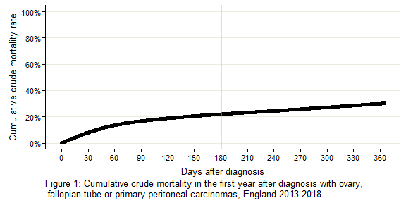
13.6% of patients diagnosed with ovarian cancer died within the first 2 months following their diagnosis, compared to 8.4% that died within 2 to 6 months following diagnosis, and 8.2% that died within 6 to 12 months following an ovarian cancer diagnosis (Figure 2).
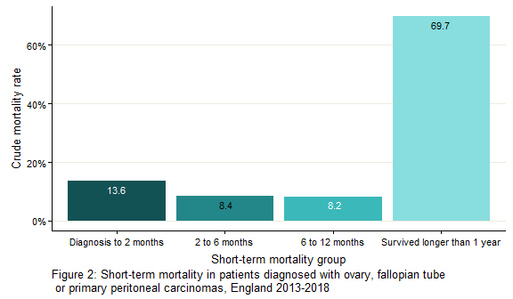
An average of 5,574 women were diagnosed with ovarian cancer per year in England between 2013 and 2018, excluding cases of borderline malignancy. The average number of women diagnosed with ovarian cancer that died within their first year after diagnosis was 1,687 per year, with an average of 758 per year dying within the first 2 months after their diagnosis.

Mortality variation by tumour site
ICD-10 (International Classification of Diseases, Tenth Revision) codes are used to classify diagnoses. For neoplasms, ICD-10 codes indicate the site of origin and type of malignant tumour. The majority (83.8%) of women included in the cohort were diagnosed with ICD-10 C56 (malignant neoplasm of ovary). All tumour sites (defined by ICD-10 code) show a similar pattern in short-term mortality, with the highest percentage of patients with short-term mortality dying within 2 months following their diagnosis. The proportion of patients that died within the first 2 months was greatest for those diagnosed with tumours of a C48 (malignant neoplasm of retroperitoneum and peritoneum) site, at 15.0% (Figure 3).
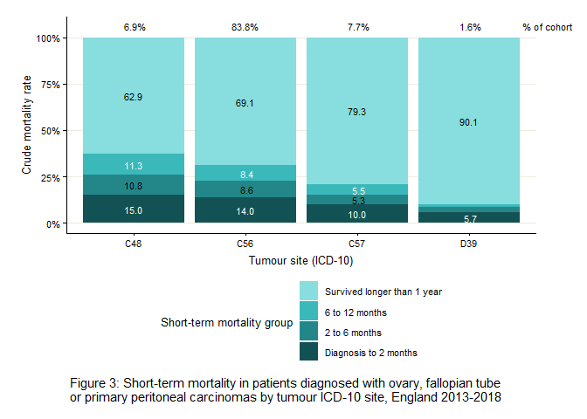

Mortality variation by tumour morphology
Figure 4 displays variation in patient mortality by tumour morphology. Tumour morphology is the histological type of cancer, determined by assessment from tissue biopsies, including the use of immunohistochemical analysis. Tumour morphology can impact the type of treatment and outcomes for a patient. This report uses the tumour morphology groups as defined in the OCAFP Disease Profile in England report and Get Data Out.^{1,5}
The majority of patients identified in our cohort were diagnosed with tumours of serous carcinoma morphology (51.0%). Mortality within 2 months following diagnosis was greatest for patients diagnosed with ‘miscellaneous and unspecified’ or ‘non-specific site’ morphologies at 51.3% and 37.5% respectively. These are patients who were likely too unwell to complete the full diagnostic process. Patients who were diagnosed with a ‘sex cord-stromal and germ cell’ morphology saw the lowest short-term mortality rates with only 0.9% of patients dying within the first 2 months following their diagnosis. Patients diagnosed with an ‘endometrioid carcinoma’ or ‘clear cell carcinoma’ morphology also had low mortality in the first 2 months after diagnosis at 1.3% and 3.0% respectively. Patients with ‘mucinous carcinoma’ or ‘serous carcinoma’ morphologies experienced higher mortality rates with 3.5% and 7.1% of patients dying within the first 2 months following diagnosis.
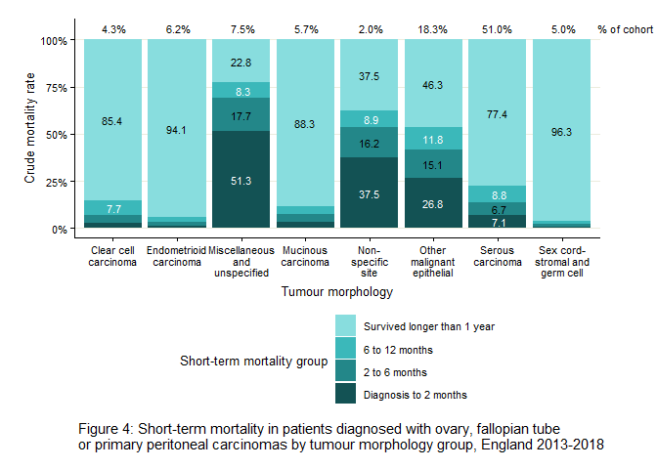

Mortality variation by basis of diagnosis
Tumours can be diagnosed in a number of ways including clinically, histologically or via cytology methods. Clinical diagnoses are made on the basis of medical signs and reported symptoms, sometimes including investigations such as diagnostic imaging, endoscopy or tumour markers. Histological diagnoses involve microscopic examination of tissue whereas cytology diagnoses involve microscopic examination of cells from fluid (ascites or pleural effusion) or fine needle aspiration sampling of solid tumour. Basis of diagnosis can give an indication of the validity of the diagnosis. Identifying the histology of a malignancy by microscopic examination is generally accepted as the most accurate method of diagnosis, however this cannot always be performed, for example if a patient is very unwell at the time of diagnosis. Patients with an unknown basis of diagnosis or those diagnosed via death certificate only, were not included in these analyses.
83.3% of patients in the cohort were diagnosed via histology compared to only 9.4% of patients having been diagnosed clinically or 7.3% by cytology. Differences in short-term mortality were most pronounced for deaths within 2 months following diagnosis. For example, 54.9% of women who were diagnosed clinically died within 2 months following diagnosis, compared to only 7.0% of patients who were diagnosed by histological investigation (Figure 5).
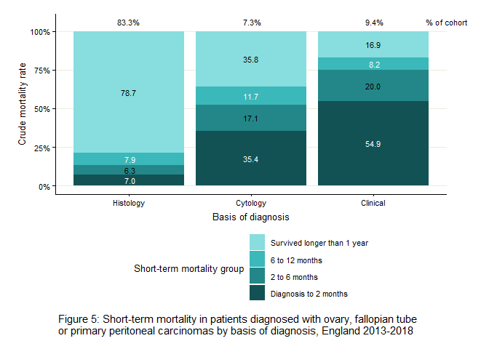

Mortality variation by stage at diagnosis
Tumour stage describes the size and severity of a patient’s tumour, including how far a cancer has spread. Diagnosing ovarian cancer in its early stage is one of the most important factors affecting good cancer outcomes.⁶ In this report, stage at diagnosis was defined by the cancer registry, which generally uses FIGO (International Federation of Gynecology and Obstetrics) for ovarian cancers. Please see Appendix 1 for a more detailed definition of stage at diagnosis.
Patients with a lower stage at diagnosis showed lower rates of short-term mortality, with only 0.8% of patients diagnosed at stage 1 having died within the first 2 months following diagnosis, compared to 21.0% of patients diagnosed at stage 4 (Figure 6). All ovarian cancers should be staged by the Multidisciplinary Team (MDT), however if a patient is too unwell at diagnosis, due to comorbidities or advanced disease, it may not be possible to perform the necessary investigations in order to capture accurate stage data. This explains why a large number of patients with an unknown stage at diagnosis die within 2 months (30.6%).
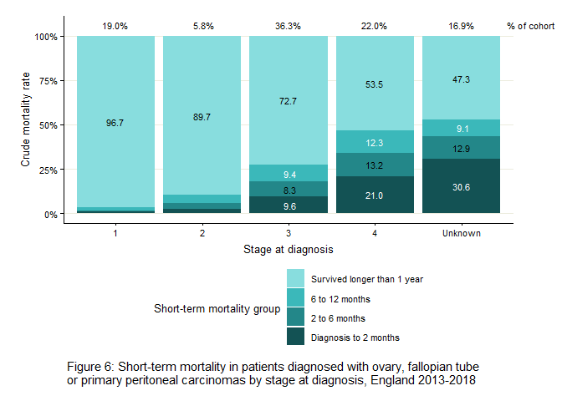

Mortality variation by route to diagnosis
Patients can be diagnosed late with advanced disease and a poor performance status due to delays in presenting for medical care, delays in primary care, delays between primary and secondary care or delays in secondary care.^{7,8} A route to diagnosis describes the pathway a patient took, and the interactions made through the healthcare system, before receiving a cancer diagnosis.⁸ In this report, routes to diagnosis were defined as emergency presentation, Two Week Wait, non-urgent or unknown route. The Two Week Wait referral system, whereby a GP urgently refers a patient to be seen within 2 weeks by a specialist, was set up in 2000 with the aim of achieving faster diagnosis for patients with suspected cancer. An emergency presentation includes diagnosis via any emergency service such as A&E admission or attendance, emergency GP Referral, emergency transfer or emergency consultant outpatient referral. Patients diagnosed by an emergency presentation generally have poor prognosis as their symptoms and stage of disease are more severe at the point that they engage with the healthcare system.⁹ 36.5% of patients in the cohort were diagnosed via the Two Week Wait route, 30.0% of patients were diagnosed via an emergency presentation, 31.2% were diagnosed via a non-urgent route and 2.3% of patients had an unknown route. ‘Non-urgent’ route includes patients that were diagnosed via GP Referral (20.2% of the patients in the cohort), Other Outpatient (9.6%) or Inpatient Elective (1.4%). More detailed descriptions of these routes to diagnosis can be found in Appendix 1.
Figure 7 shows notable differences in mortality by route to diagnosis. Across all 3 short-term mortality timeframes, mortality rates were highest in ovarian cancer patients who were diagnosed via an emergency presentation, with 30.8% having died within 2 months from diagnosis, 13.2% within 2 to 6 months and 9.8% within 6 to 12 months. Women that were diagnosed via the Two Week Wait referral system showed the lowest mortality rates for patients that died within 2 months (4.6%) and 2 to 6 months (5.9%) from diagnosis. Patients diagnosed via a non-urgent GP Referral generally had higher mortality as these patients may experience longer delays in diagnosis, allowing the disease more time to progress, leading to poorer survival.
Ovarian cancer patients with an unknown route to diagnosis show high mortality rates within 2 months from diagnosis (12.3%). An unknown route is assigned when there is no useful information found for the patient in the Hospital Episode Statistics (HES) data 6 months prior to diagnosis, or the Cancer Waiting Time (CWT) dataset. This could include patients who have received diagnosis or treatment in private hospitals. Other reports have found that patients with an unknown route to diagnosis have similar survival to other non-emergency routes.⁸ However, patients in this cohort with ‘non-urgent’ routes show much lower mortality rates within 2 months from diagnosis compared to patients diagnosed with an unknown route (7.6%).
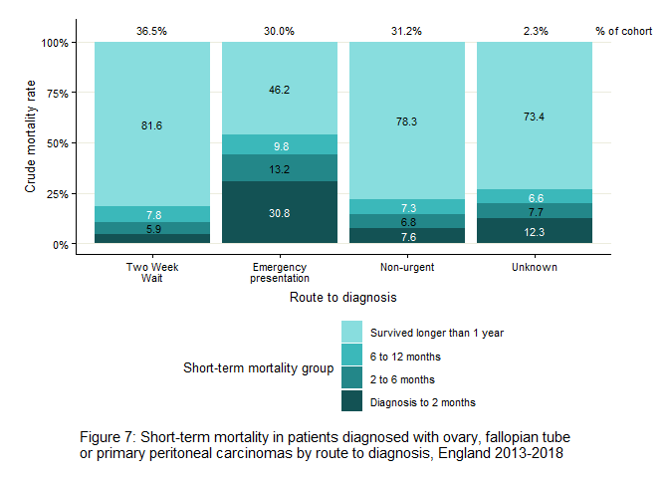

Mortality variation by patient age at diagnosis
Figure 8 shows that short-term mortality was higher in patients who were of an older age at the point of diagnosis. Older patients are more likely to have more severe and more numerous comorbidities as well as a poorer performance status than younger patients, and therefore will be less likely to receive treatment with curative intent. 34.8% of patients aged 80 years and over died within 2 months following their diagnosis, compared to only 0.7% of patients aged 0-29 years. 95.6% of patients aged 0-29 years survived longer than 1 year.
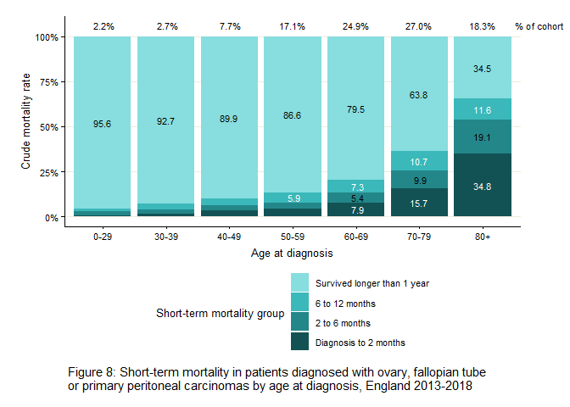

Mortality variation by deprivation
Socioeconomic differences in ovarian cancer patient mortality may be due to differences in tumour morphology, patient knowledge around symptoms, access to a GP, or differences in treatment.¹⁰ The Index of Multiple Deprivation (IMD) measures relative levels of deprivation in small geographical areas, to which all persons within that area are assigned the same deprivation level. The IMD takes into account many factors relating to low socioeconomic status including employment, education, skills and training, disability, crime, barriers to housing and services, living environment and income. Patients were assigned into ordered quintiles, based on their postcode at diagnosis, where 5 is the least deprived and 1 is the most deprived.
16.3% of women were living in the most deprived areas at the time of diagnosis compared to 21.8% of women living in the least deprived areas at the time of diagnosis. Figure 9 shows that the proportion of women who died within 2 months following diagnosis was slightly higher for those living in areas of greater deprivation than among women in areas of lower deprivation. 12.0% of ovarian cancer patients that were resident in the least deprived quintile died within 2 months following diagnosis, compared to 16.2% within the most deprived quintile.
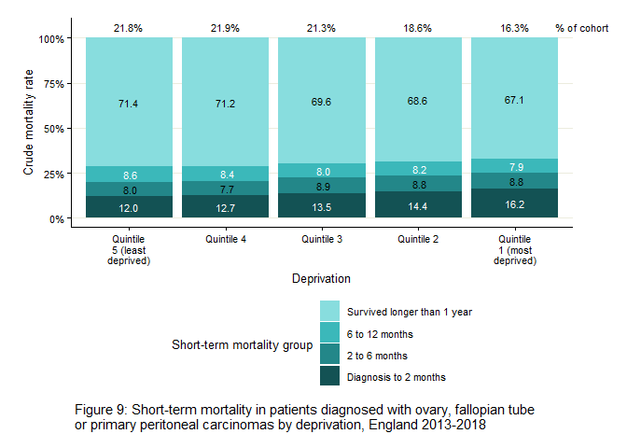

Mortality variation by ethnicity
Figure 10 displays that some variation in ovarian cancer patient mortality exists by ethnicity. 88.5% of patients in the cohort were of white ethnicity. 13.5% of white female patients died within 2 months following diagnosis. All other ethnicities had lower mortality rates within the same time period, particularly Asian women at 6.9%. Patients with an unknown ethnicity had the highest short-term mortality rates with 24.1% of patients dying within the first 2 months following diagnosis. Given the low number of patients recorded with non-white ethnicities in the cohort, it is possible that many patients with an unknown ethnicity are women of mixed or non-white ethnicities and that these ethnicities may have mortality rates much higher than presented in Figure 10.
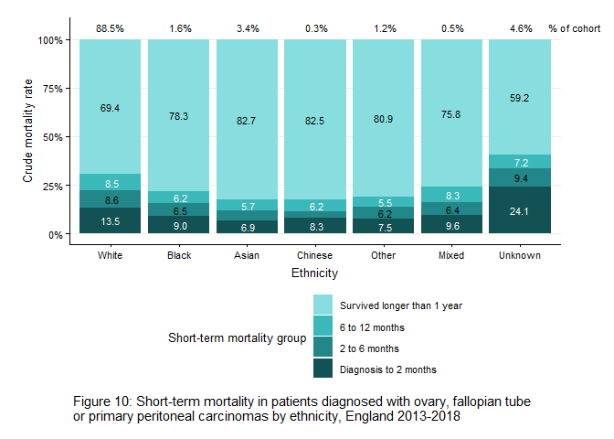

Mortality variation by comorbidity
Comorbidities and cancer are more likely with an ageing population and may mean patients have fewer options for treatment.¹¹ Patients with severe comorbidities may be too unwell to receive curative treatment and therefore show poorer survival. To investigate differences in short-term mortality by comorbidity in this report the Charlson comorbidity index was used. This index describes the burden of pre-specified comorbid conditions within patients, and was developed to predict one-year mortality in hospital patients.¹² Comorbidities included in the index, and scores for each condition are listed in Appendix 11. Comorbidity scores were assigned to tumours based on the number and burden of comorbidities recorded within the HES admitted patient care dataset or cancer registry data, occurring between 3 and 27 months prior to the cancer diagnosis of interest. Higher scores are indicative of a greater burden of comorbid disease. A Charlson comorbidity index score of 0 indicates that a patient did not have any other cancers or any of the comorbidities listed in Appendix 11 recorded in the cancer registry or HES admitted patient care dataset within the time period specified. This means that patients with comorbid conditions not considered in Appendix 11 or only documented within an outpatient or primary care setting will have a score of 0. A score of 1 indicates that a patient did have a comorbidity recorded within the specified time period, and a score of 2 or higher indicates that a patient has multiple or a single severe comorbidity recorded within the time period. Where a patient could not be linked to HES, a Charlson score was assigned as ‘not recorded’. Please see Appendix 1 for more details about how Charlson comorbidity has been defined in this report.
84.3% of patients in the cohort did not have any record in HES admitted patient care or cancer registry data of pre-specified comorbidity between 3 and 27 months prior to the cancer diagnosis of interest. 8.1% of patients in the cohort had a comorbidity index score of 1 and 2.8% of patients had a comorbidity score of more than 2. The high proportion of patients with no recorded comorbidity indicates that inpatient HES is not a sensitive process for capturing comorbidity in this cohort and likely markedly underreports it. Figure 11 shows that short-term mortality was greater in patients with higher burdens of comorbidity. For example, 11.9% of ovarian cancer patients with no recorded comorbidities, died within 2 months following their diagnosis. Conversely, 34.9% of ovarian cancer patients with a comorbidity score of more than 2, died within 2 months following their ovarian cancer diagnosis.
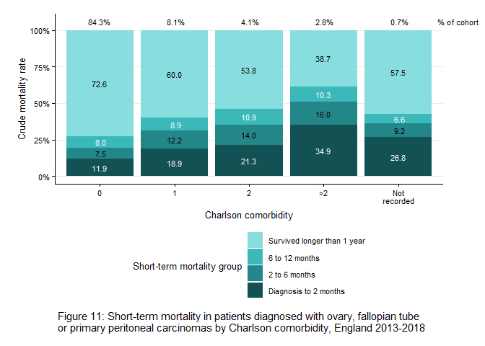

Mortality variation by WHO performance status
Performance status is a measure of a patient’s ability to undertake daily living activities. This is captured as a score between 0 and 4, where 4 indicates complete disability and total confinement to a bed or chair. Performance status is known to be an important factor in ovarian cancer survival and may explain why a patient did not receive treatment or a histological diagnosis. In this cohort, 63.4% of patients did not have their performance status recorded at diagnosis. Figure 12 shows that of those patients that did have a performance status recorded at diagnosis, patients with higher values (i.e. less physical function) had higher rates of short-term mortality. 2.4% of patients with a performance status of 0 died within 2 months following diagnosis, compared to 62.7% of patients with a performance status of 4.
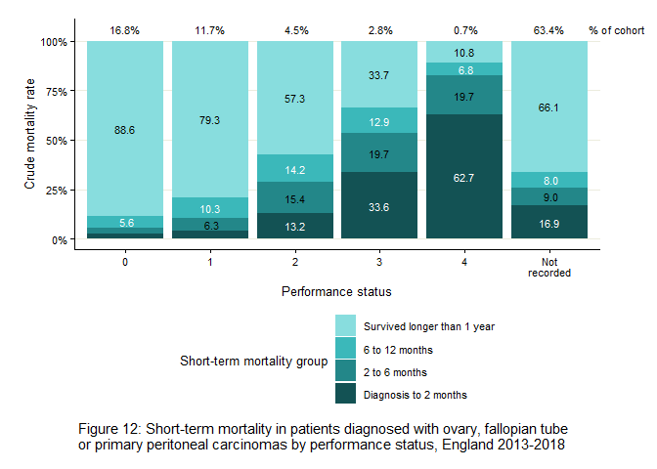

Mortality variation by treatment
Based on the type of treatment and the order in which treatment was received, each patient was assigned to one of the following treatment categories following the method outlined in the OCAFP Geographic variation in ovarian, fallopian tube and primary peritoneal cancer treatment in England report:¹
- No surgery or chemotherapy
- Primary surgery with adjuvant chemotherapy (i.e. surgery followed by chemotherapy)
- Neoadjuvant chemotherapy with interval debulking surgery (i.e. chemotherapy followed by surgery)
- Chemotherapy but no surgery
- Primary surgery but no chemotherapy
The OCAFP treatment report found that women with stage 4, or unknown stage of disease at time of diagnosis, and tumours with a miscellaneous and unspecified morphology were much less likely to receive any treatment. Women with comorbidities were less likely to receive surgery, and older women were more likely to have no treatment or only chemotherapy.¹
In this report 20.3% of patients in the cohort did not have any treatment recorded between 1 month prior and 9 months following diagnosis. Figure 13 shows that most patients that did not receive any surgery or chemotherapy treatment died within 2 months following diagnosis (56.9%). This could have been because patients presented with advanced disease, high burden of comorbidity or poor performance status, limiting treatment options. Very few patients that died within 2 months from diagnosis received both chemotherapy and surgery (0.3%).
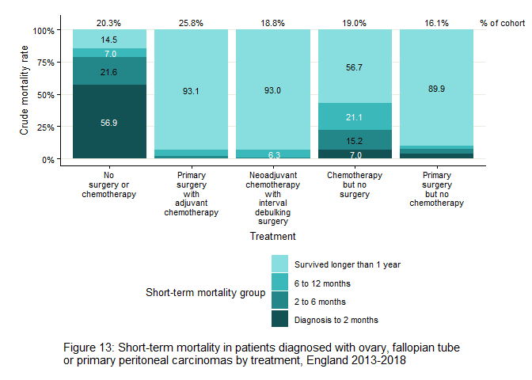

Mortality variation by cancer centre
Cancer Units provide diagnostic services for their local populations and refer cases of suspected or confirmed ovarian cancer to their local specialist gynaecological cancer centre. Cancer centres house specialist gynaecological oncology MDTs and provide diagnostic and treatment services for patients referred from local Cancer Units. In 2021 there were 40 specialist gynaecological cancer centres in England. 55.8% of patients in this cohort were diagnosed at a trust that housed a cancer centre in 2021. Figure 14 shows that 18.0% of patients diagnosed at a trust that did not house a cancer centre died within the first 2 months following diagnosis, compared to only 10.1% of patients that were diagnosed at a trust that had a cancer centre.
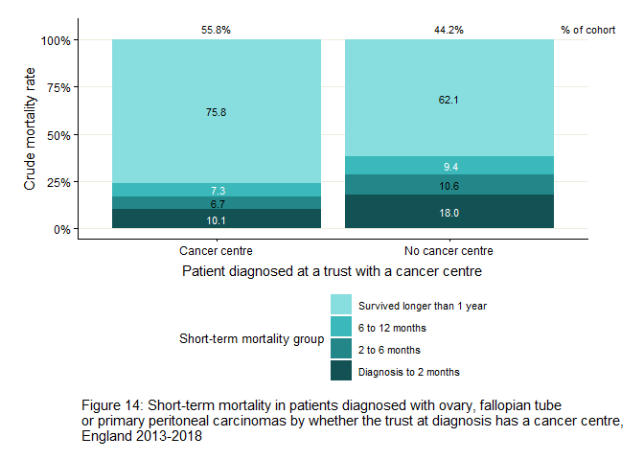
Figure 15 displays the percentage of patients in the cohort by route to diagnosis and availability of a specialist gynaecological cancer centre at the trust of diagnosis. There were more emergency presentations among ovarian cancer patients who are diagnosed at a trust without a cancer centre than those who were diagnosed at a trust with a cancer centre, at 57.5% compared to 48.3% respectively. This figure is only based upon ovarian cancer patients who died within 1 year of diagnosis.
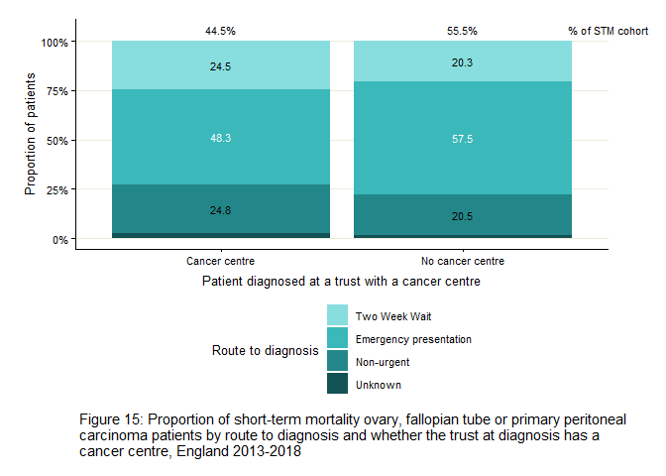

Mortality variation by GP to population ratio
The ratio of GPs to the local general population could impact on the time to patient referral and diagnosis, and thereby prognosis. The mean number of GPs per Clinical Commissioning Group (CCG) during 2018 was 189 (min=39, max=927). The GP to population ratio was calculated as the number of registered GPs per 10,000 population in a CCG in 2018. A lower GP to population ratio indicates that there were fewer GPs per 10,000 population in the CCG. The average GP to population ratio across the 195 CCGs was 6.6, with values ranging from 3.5 to 10.8. The GP to population ratios were split into tertiles for analysis; low=3.53-5.94, medium=5.95-7.09, high=7.10-10.84. Figure 16 shows that 13.8% of patients that died within 2 months from diagnosis lived in a CCG that had a low GP to population ratio per 10,000, compared to 13.5% of patients that lived in a CCG that had a high GP to population ratio per 10,000. When looking at urgent referrals, Mendonca et al (2018) found that there was no association with the number of patients registered with a GP, or a GP practice location (rural vs urban), but that there was some variation in urgent referrals by practice characteristics such as age of GPs.¹³
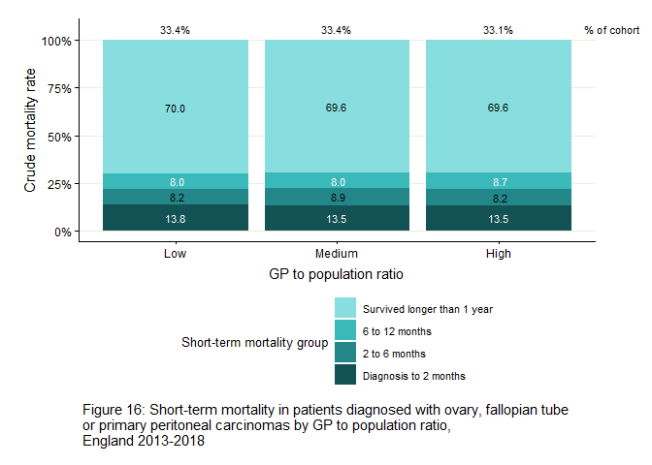

Adjusted mortality rates
P-values from chi-squared tests found mortality was significantly different (p=<=0.001) across all 3 short-term mortality time periods by the following factors: tumour site, tumour morphology, stage at diagnosis, basis of diagnosis, route to diagnosis, treatment, patient age at diagnosis, ethnicity, comorbidity, WHO performance status and whether the trust at diagnosis housed a specialist gynaecological cancer centre (Appendix 2, Table 2). Short-term mortality was significantly different by IMD quintile only for patients who died within 2 months (p=<=0.001), or 2 to 6 months (p=0.004) following a diagnosis. GP to population ratio was not significantly associated with short-term mortality.
Factors that were found to have a significant difference in mortality were considered for inclusion in the mixed effects logistic regression models to estimate the association of factors within each of the short-term mortality time periods. A priori knowledge and model fit also led factor selection. The multivariable analysis model adjusted for the following covariates: age at diagnosis, tumour morphology, stage at diagnosis, deprivation quintile, ethnicity, comorbidity, route to diagnosis and whether the trust at diagnosis housed a specialist gynaecological cancer centre. For diagnosis to 2 months only, basis of diagnosis was also included to adjust for lead time bias, whereby patients who received a histological diagnosis will likely be those who lived long enough to receive a tissue biopsy (up to 2 weeks may elapse between an initial clinical and subsequent histological diagnosis). Trust at diagnosis was also included as a random effect accounting for patients clustered within hospital trusts.
Tumour site was not included in the models as a priori knowledge suggested tumour morphology was a better measure of tumour type. Due to the high percentage of missing performance status data, this covariate was not included in the logistic regression models. A sensitivity analysis is available in Appendix 9 which investigates the association between performance status at diagnosis and ovarian cancer patient short-term mortality between 0 and 2 months from diagnosis. Treatment was also not adjusted for in the models based on a priori knowledge that many patients who exhibit short-term mortality will not receive any treatment. Treatment would also act as a mediator in many relationships with other covariates and may therefore bias the estimates of the models if it was included.
Results from the maximally adjusted and the minimally adjusted models (without route to diagnosis and whether the trust at diagnosis housed a cancer centre) are displayed in Appendices 3-5.
Adjusted mortality rates from the mixed effects logistic regression models show that mortality was consistently higher across all short-term mortality groups for patients diagnosed with ‘miscellaneous and unspecified’, ‘mucinous carcinoma’, ‘non-specific site’ and ‘other malignant epithelial’ morphologies compared to tumours of a ‘serous carcinoma’ morphology. Odds ratios for these groups, relative to ‘serous carcinoma’, ranged between 1.7 (95% CI 1.3-2.2) in patients with ‘mucinous carcinoma’ morphology and 3.0 (95% CI 2.5-3.5) in patients with ‘miscellaneous and unspecified’ morphology for those that died within 2 months of diagnosis. Patients with a ‘clear cell carcinoma’ morphology also showed significantly higher odds of dying within 2 to 6 months (OR 1.9 95% CI 1.4-2.6) or 6 to 12 months (OR 2.6 95% CI 2.1-3.2) compared to patients with ‘serous carcinoma’ morphologies. Across all 3 short-term mortality groups, women with a ‘sex cord-stromal and germ cell’ morphologies showed the lowest odds of mortality compared to ‘serous carcinomas’.
Adjusted odds ratios from the maximally adjusted model investigating mortality between 0 and 2 months from diagnosis show that patients diagnosed clinically (OR 2.4 95% CI 2.1-2.8) or by cytology (OR 2.2 95% CI 1.9-2.4) are significantly more likely to die within 2 months from diagnosis than patients diagnosed via histological examination.
Adjusted mortality rates also show the odds of short-term mortality were significantly higher in women whose cancer was more advanced at diagnosis. Patients diagnosed at stage 4 showed the highest risk of mortality compared to patients diagnosed at stages 1-3 or an unknown stage (0 to 2 months: OR 10.2 95% CI 7.6-13.7, 2 to 6 months: OR 16.8 95% CI 12.3-22.9, 6 to 12 months: OR 10.8 95% CI 8.6-13.7). Patients with an unknown stage at diagnosis also had a higher risk of mortality than patients diagnosed within stages 1-3 (0 to 2 months: OR 9.5 95% CI 7.1-13.7, 2 to 6 months: OR 11.6 95% CI 8.5-15.9, 6 to 12 months: OR 7.3 95% CI 5.8-9.4).
Patients diagnosed via an emergency presentation had the highest likelihood of mortality across all short-term mortality time periods compared to patients diagnosed via a Two Week Wait route (0 to 2 months: OR 4.3 95% CI 3.9-4.8, 2 to 6 months: OR 2.4 95% CI 2.1-2.6, 6 to 12 months: OR 1.7 95% CI 1.6-1.9). Patients diagnosed via a non-urgent route also showed significantly higher odds of mortality during 0 to 2 months (OR 1.5 95% CI 1.3-1.7) and 2 to 6 months (OR 1.2 95% CI 1.1-1.4) than patients diagnosed via a Two Week Wait route.
Short-term mortality was significantly higher in patients who were of an older age at the point of diagnosis across all short-term mortality groups following adjustment for confounding variables. Odds of death were highest for patients aged 80 years and over at diagnosis when compared to patients aged 70-79 years (0 to 2 months: OR 1.4 95% CI 1.3-1.6, 2 to 6 months: OR 2.3 95% CI 2.1-2.6, 6 to 12 months: OR 1.7 95% CI 1.5-1.9). All younger age groups had a significantly lower odds of short-term mortality when compared to patients aged 70-79 years.
Logistic regression models showed that mortality risk increased with a more deprived deprivation quintile. Patients within the most deprived quintile had a 50% higher risk of mortality within 0-2 months from diagnosis and 40% higher risk of mortality within 2 to 6 months from diagnosis when compared to patients in the least deprived quintile (0 to 2 months: OR 1.5 95% CI 1.4-1.8, 2 to 6 months: OR 1.4 95% CI 1.2-1.6). The differences in mortality rates by deprivation quintile were not significant for patients that died within 6 to 12 months.
After controlling for confounding variables, minimal variation in ovarian cancer patient short-term mortality remained across ethnicity groups, though patients of an unknown ethnicity still had significantly higher odds of mortality within 2 months following diagnosis compared to patients of white ethnicity (OR 1.5 95% CI 1.3-1.8). Patients that died within 0 to 2 (OR 0.7 95% CI 0.5-0.9) or 2 to 6 months (OR 0.7 95% CI 0.5-0.9) had significantly lower odds of mortality if they were of Asian ethnicity compared to patients of white ethnicity.
Logistic regression models showed that patients with a recorded comorbidity (Charlson score of 1, 2 or >2), or a Charlson score not recorded, showed higher odds of mortality compared to patients with a Charlson score of 0. Across all short-term mortality periods, patients with a Charlson comorbidity score of more than 2 showed significantly higher odds of mortality than patients with a Charlson score of 0 (0 to 2 months: OR 1.6 95% CI 1.3-1.9, 2 to 6 months: OR 1.8 95% CI 1.4-2.2, 6 to 12 months: OR 1.5 95% CI 1.2-1.9).
Multivariable models that adjusted for confounding factors found that patients diagnosed in a trust that did not have a specialist gynaecological cancer centre had significantly higher odds of short-term mortality only between 2 and 6 months following diagnosis than patients who were diagnosed in a trust that did have a cancer centre (OR 1.2 95% CI 1.1-1.4).

Mortality by Cancer Alliance
Mortality rates by Cancer Alliance at diagnosis (using the 19 Alliances as defined for England in 2018) were found to be significantly different across all short-term mortality time periods (p=<=0.001) (Appendix 2, Table 2). To estimate the magnitude of variation in short-term mortality between the Alliances, crude and adjusted mortality rates were presented in funnel plots in Figures 17-22 (also tabulated in Appendices 6-8).¹⁴
Each point on the funnel plot represents a Cancer Alliance. The number of ovarian cancer patients diagnosed in the Cancer Alliance between 2013 and 2018 is shown on the horizontal axis, and the crude or adjusted mortality rate is shown on the vertical axis. The average mortality rate for ovarian cancer patients in England between 2013 and 2018 is indicated by the red horizontal line. A Cancer Alliance with a mortality rate above this average line suggests that patients in this Cancer Alliance have a higher mortality rate than expected for the size of the Alliance, and vice versa for points below the line. The 2 pairs of dashed lines on the funnel plot indicate the bounds of statistical confidence around the average. The inner lines represent 2 standard deviations (SD) from the population average and the outer set represents 3 SDs, being approximately equivalent to 95.0% and 99.7% confidence intervals respectively. Observations outside of these lines had a confidence interval that did not include the average mortality rate for the cohort and may therefore indicate a systematic deviation in clinical practice that warrants further investigation. However, some random variation in short-term mortality is expected between Alliances such that some points will sit outside the dashed lines through chance alone. This should be taken into consideration when interpreting funnel plots (for example, five out of every 100 observations are likely to lie outside the 2 SD funnel). Please see Appendix 1 for a more detailed methodological description.

Mortality by Alliance within 2 months from diagnosis
The average crude mortality rate for ovarian cancer patients in the first 2 months following diagnosis across England was 13.3%. Figure 17 shows that some variation did exist between Cancer Alliances. 4 Cancer Alliances fell 2 SDs below the population average, indicating that patients diagnosed within these Alliances have a significantly lower mortality rate within the first 2 months following diagnosis. 3 Cancer Alliances fell 2 SDs above the population average, indicating that patients diagnosed within these Alliances have a significantly higher mortality rate within the first 2 months following diagnosis. The adjusted average mortality rate for ovarian cancer patients in the first 2 months following diagnosis was 13.5%. Figure 18 shows that after adjustment for the covariates of interest (basis of diagnosis, age at diagnosis, tumour morphology, stage at diagnosis, route to diagnosis, deprivation quintile, ethnicity, comorbidity, whether the trust at diagnosis housed a specialist gynaecological cancer centre and trust at diagnosis as a random effect), some geographical variation remained although it was reduced. There were no Cancer Alliances that had an adjusted mortality rate outside of 2 standard deviations. Due to the reduced variation we can conclude that some of the geographical variation can be partly explained by the factors adjusted for in the model.
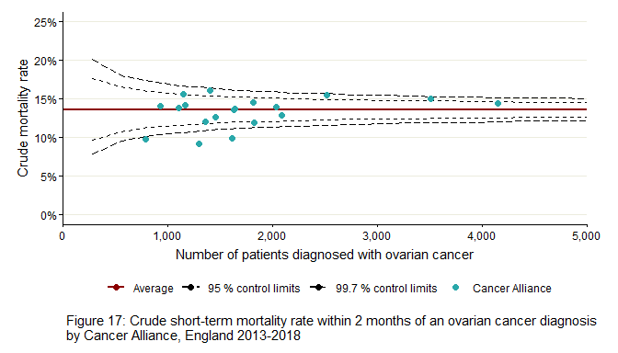
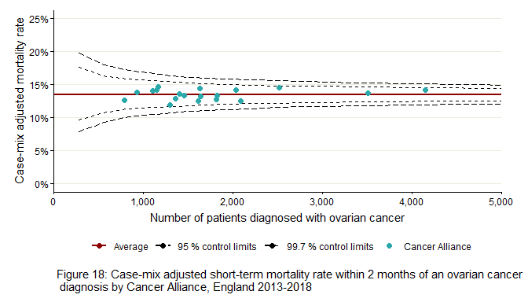

Mortality by Alliance within 2 to 6 months from diagnosis
The crude average mortality rate for ovarian cancer patients who survived longer than 2 months but died within 6 months following diagnosis was 9.4% and the case-mix adjusted average mortality rate was 9.6%. Crude mortality rates in Figure 19 show that there were 4 Cancer Alliances that fell 2 SDs below the population average and 3 Alliances that were 2 SDs above the population average. Figure 20 shows that controlling for the covariates of interest reduced variation between Alliances such that none had significantly different rates to the average.
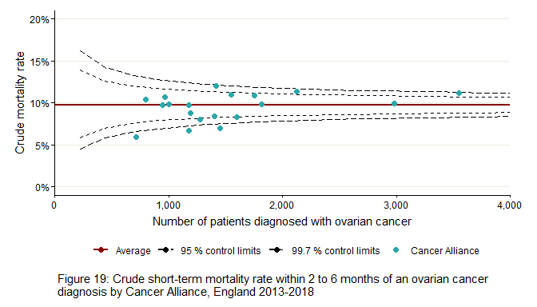
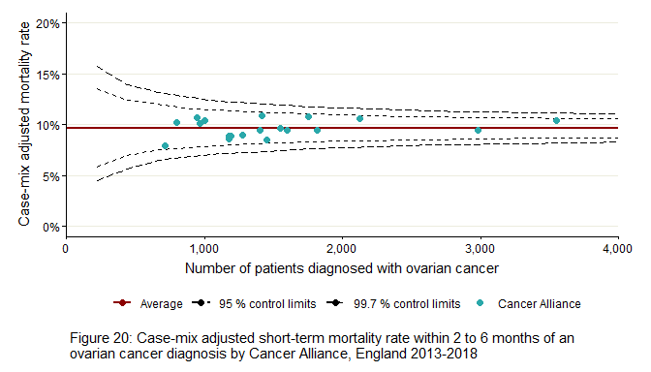

Mortality by Alliance within 6 to 12 months from diagnosis
Both the crude and case-mix adjusted average mortality rate for ovarian cancer patients who survived longer than 6 months but died within 12 months following diagnosis was 10.5%. Figure 21, displaying crude mortality rates for the period 6 to 12 months following diagnosis, shows that there were 4 Cancer Alliances that had a mortality rate below 2 SDs of the cohort average. There are also 3 Alliances with a mortality rate 2 SDs above the average. After case-mix adjustment (Figure 22) some variation remains with one Alliance falling above 2 standard deviations from the average. All other Alliances had mortality rates inside of 2 standard deviations from the average suggesting that most of the differences in short-term mortality between Alliances was due to confounding factors that have been adjusted for.
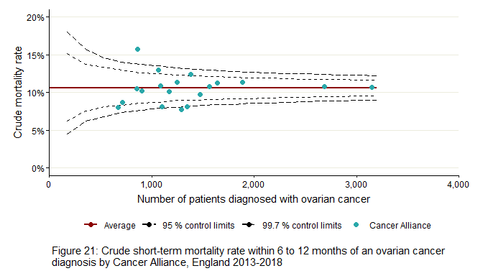
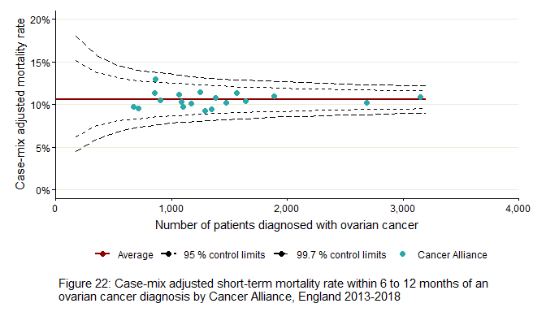

Conclusion
Short-term mortality rates for ovarian cancer patients across the first year after diagnosis remain high, particularly within the first 2 months. Mortality rates within 1 year of diagnosis from this report (30.3%) are similar to the previous NCIN report covering 2006 to 2008 (31%).² However, the cohort in this report does exclude borderline tumours, which have a very low mortality rate, and includes primary peritoneal cancers, which have a high rate of short-term mortality, suggesting that outcomes of mortality within 1 year of diagnosis may have improved more than the 0.7% difference reported. Mortality rates within 1 year of diagnosis have also improved slightly from the NCIN report covering 2008 to 2010, which had a closer matching cohort definition to this report and found that 36% of patients died within 1 year following diagnosis.³
Mixed effects logistic regression models examined factors that were associated with ovarian cancer patient mortality across the first year after diagnosis. Most variation in mortality rates between women of different tumour characteristics and patient demographics was found to exist in the shortest time period investigated; diagnosis to 2 months.
Analysis identified patients about which little is known, due to missing data, who have a consistently higher risk of dying within the first year following diagnosis. The poor data quality may be due to their short survival times or poor performance status making diagnostic investigations inadvisable, meaning there is no pathological confirmation of their diagnosis, no staging data and no morphology data for their tumour. These poor outcomes are reflected in the OCAFP Treatment report, where the same cohort are also the least likely to receive effective anticancer treatments including chemotherapy and surgery.¹ Additionally, mixed effects logistic regression models found that patients with a cytology or clinical basis of diagnosis were found to have a significantly higher risk of death within the first 2 months after diagnosis compared to patients who had a histological diagnosis.
There are also distinct patient and tumour characteristics linked with a higher risk of dying in the first year following an ovarian cancer diagnosis. These include age (with older patients having a higher risk of dying), stage (with stage 4 patients having the highest risk of dying), a higher burden of comorbidities, emergency presentation and a more deprived IMD quintile. For those women in the most deprived quintile, the risk of dying from ovarian cancer within the first 2 months following diagnosis significantly increases by 50% when compared to women in the least deprived quintile. The low percentage of patients diagnosed with ovarian cancer living in the most deprived areas may indicate underdiagnosis in this group, possibly due to barriers to accessing care.
The data shows that patients diagnosed via an emergency presentation had the highest likelihood of mortality across all short-term mortality time periods. It is known that patients diagnosed from emergency presentations generally suffer worse outcomes due to advanced stage of disease.¹⁵ Analysis also shows that women referred to diagnosis by the non-urgent route have significantly higher rates of short-term mortality within 0 to 2 months and 2 to 6 months from diagnosis than those placed on an urgent GP referral by Two Week Wait. This suggests either that women are not being referred urgently when they should be, are not being seen quickly enough through a non-urgent referral or are being referred to a different specialty for assessment of the non-specific symptoms of ovarian cancer, delaying the diagnostic process and resulting in poorer prognosis. A supplementary graph of route to diagnosis by Cancer Alliance for ovarian cancer patients with short-term mortality is displayed in Appendix 10.
The data also shows that whether or not women are diagnosed within a specialist gynaecological cancer centre, with the more specialist care this offers, impacts on their risk of dying. Within 2 months of diagnosis nearly twice as many women (18%) diagnosed at a trust that did not have a cancer centre die within 2 months. After adjustment for confounding variables, this effect remained significant for patients dying within 2 to 6 months from diagnosis. This could be because diagnosis and progression to first treatment pathway is more efficient if the patient is diagnosed by a trust with a gynaecological cancer centre. This may partly be due to a greater awareness of ovarian cancer amongst other services within the hospital, such as care of the elderly, gastroenterology, colorectal surgery, respiratory teams etc.
Although some variation in short-term mortality exists between Cancer Alliances, case-mix adjusted mortality rates suggest that much of this variation can be explained by the different patient populations, rather than actual geographical differences in diagnosis and treatment for ovarian cancer patients between Cancer Alliances. This is in contrast to other indicators, including the variation in survival at CCG level found in the OCAFP Profile report¹. It is therefore possible that any geographic variation that does exist has a smaller footprint than a Cancer Alliance. Although the OCAFP profile report found large differences at Cancer Alliance level for net survival rates, the methodology in this report does differ displaying mortality rates as opposed to net survival rates. Furthermore, the net survival rates in the profile report are only standardised by patient age at diagnosis. The mortality rates in this report adjust for many additional variables which may help to explain some of the short-term mortality variation seen at Alliance level e.g. stage at diagnosis or route to diagnosis. Both reports found that South East London Cancer Alliance had the lowest ovarian cancer patient short-term mortality rate and South Yorkshire, Bassetlaw, North Derbyshire and Hardwick Cancer Alliance had the highest rate. In addition, the Alliances that were less likely to deliver any treatment from the OCAFP treatment report show greater rates of short-term mortality in this report.¹
In conclusion, the data presented here shows the difference diagnosing women at an early stage makes, and the benefits of specialist provision. It also demonstrates worrying inequalities in outcomes for women from poorer backgrounds. Identifying how to ensure all women have timely access to appropriate treatment and addressing any barriers they face will be critical in reducing the number of women dying within the first year of diagnosis. Future research could examine the significance of comorbidities using patient frailty, as described by Gilbert et al (2018), as opposed to the Charlson index which demonstrates an underestimate of comorbidities in this cohort of patients.¹⁶ In addition, the differences in short-term mortality between women diagnosed at specialist gynaecological cancer centres vs those that are not warrants further investigation. Finally, future research could further investigate variation in short-term mortality at a more granular geographical level e.g. trust.

Limitations

Data completeness
Missing data was evident for performance status (63.4%), Charlson comorbidity index (0.7%), ethnicity (4.6%), routes to diagnosis (2.3%) and stage at diagnosis (16.9%). Missing data can still provide useful insight for some covariates, for example patients with an unknown stage at diagnosis could indicate the patient was too unwell to receive histological staging. For covariates with small proportions of missing data, missing cases were grouped in to an ‘unknown’ bucket. This allows for patients with missing data to be included in analyses, however care should be taken during interpretation as missing data can lead to biased estimates and invalid conclusions, due to either inaccurate estimates or heterogeneity in the cases with missing data.¹⁷ The percentage of missing data for performance status was much higher, at over half of the cases. For this reason, performance status was included only by way of a sensitivity analysis as reported in Appendix 9.

Charlson comorbidity scores
Charlson comorbidity scores were defined for each tumour by linking to non-ovarian primary cancers in the cancer registry or pre-defined comorbid medical conditions documented within an inpatient setting prior to the diagnosis of ovarian cancer. A list of medical conditions considered as comorbidities and the score assigned to each is described in Appendix 11. This list is not exhaustive. As such, the Charlson comorbidity score may be an underestimate of a patient’s true comorbidity burden. This derivation is such that the score is dependent on the recording of particular diagnoses (listed in Appendix 11) during patient admission, and may therefore underestimate the burden of comorbidity by missing diagnoses that are exclusively documented in outpatient or primary care settings, are not listed in Appendix 11 or occur outside of the time period of between 3 and 27 months prior to the cancer diagnosis of interest. However, a comparison of Charlson comorbidity indexes derived for a fixed general population cohort of adults aged >20 years found that an index based on secondary care data performed at least as well as one that utilised primary care data for the prediction of case-mix adjusted all-cause mortality.¹⁸
Despite this, the index does not reflect the true burden of all comorbid disease that may influence clinical decision making. In addition to potential limitations of the index itself, in relation to ovarian cancer, 84.3% of patients in the cohort were assigned a Charlson comorbidity score of zero, representing patients without any record of another primary cancer in the cancer registry or a predefined comorbid medical condition documented within an inpatient setting within the specified time period. That more than four-fifths of tumours in the cohort received a comorbidity score of zero sits at odds with the age profile of the ovarian cancer cohort, and research elsewhere for other tumour sites that demonstrated a broad range of comorbid medical conditions.¹⁹ Nevertheless, the Charlson comorbidity index captures at least some of the variation in the short-term mortality, whereby patients with higher scores were reported as having higher rates of short-term mortality.

Residual confounding
The logistic regression models attempt to control for bias by cofounder adjustment of numerous patient demographics and tumour characteristics between Cancer Alliances that might confound the main association under study. Despite this adjustment, there is still likely to be some residual confounding remaining which has not been accounted for. Some of the differences seen may be attributable to residual confounding rather than real disparities in clinical practice, such as geographic differences in patient frailty or treatment which have not been adjusted for in the models.

Geographies
Cancer Alliances and CCGs (used to assign GP to population ratio) were derived according to the residence of patients at the time of their respective diagnosis. This may have differed from the location of the hospital(s) at which a patient was diagnosed or treated. Cancer centres were derived from the trust at which a patient was diagnosed and whether the trust had a specialist gynaecological cancer centre as of 2021. Patients may receive diagnosis, care or treatments at multiple hospitals (and possibly across different Cancer Alliances and CCGs). Therefore, it is possible that variation in outcomes is a result of this effect, rather than differing practice. Adjusting for trust at diagnosis as a random effect in the models may have helped to control for some of this variation.

Deprivation
Deprivation was also assigned according to the residence of patients at diagnosis. People in England can move residence frequently, and with deprivation being linked to more long-term factors, the deprivation for the area of residence at the time of diagnosis may not be an accurate reflection of the patient’s deprivation status. In addition to this, deprivation is a geographical measure applied to an individual so there is possibility for ecological fallacy.²⁰

GP to population ratio
The GP to population ratio uses GP headcounts rather than the number of full-time equivalent GPs. The term “headcount” relates to distinct individuals and includes full-time and part-time GPs, and GPs in training. Care should be taken when interpreting this data as it does not show the number of full-time equivalent GPs (summing part-time hours of multiple staff), and therefore will not reflect the number of hours GPs work in the day and the potential number of patients that can been seen by the practice. Moreover, the GP ratio of the CCG may shift over time and so at 2018 may not be reflective of the ratio when the patient first interacted with the healthcare system.

Appendix 1: Methodology

Cohort definition
Women diagnosed with ovary, fallopian tube and primary peritoneal carcinomas (‘ovarian cancers’) between 1st January 2013 and 31st December 2018 in England were included in the cohort. Data were extracted for finalised registrations from the National Cancer Registration dataset for England within the National Disease Registration Service.²¹ Cases were identified according to the following ICD-10/O-2 codes:
- C56 (malignant neoplasm of ovary); or,
- C57 (malignant neoplasm of other and unspecified female genital organs); or,
- C48 (malignant neoplasm of retroperitoneum and peritoneum), excluding sarcomas: 8693, 8800, 8801, 8802, 8803, 8804, 8805, 8806, 8963, 8990, 8991, 9040, 9041, 9042, 9043, 9044, 8810, 8811-8921, 9120-9373, 9490, 9500, 9530-9582; or,
- D39.1 (neoplasm of uncertain or unknown behaviour of ovary).
Only patients with a gender of female recorded at diagnosis were included in the cohort to minimise the risk disclosure associated with transmen who retain ovaries.

Exclusions
Borderline malignancies were excluded from the cohort as these patients do not exhibit short-term mortality to be studied and could inflate the estimates. Borderline malignancies were defined as tumours with an ICD-10 site code of C56, C57 or C48 and morphology code in ICD-O-2 8442, 8444, 8451, 8463, 8473, 8472 or 8462, or tumours with ICD-10 site code D39.1 and morphology code in ICD-O-2 8144, 8260, 8313, 8380, 8381, 8440, 8441, 8460, 8470, 8480, 8481, 9000, 9013, 9014 or 9015.
Patients were also excluded from the analysis due to the following data quality reasons; missing NHS numbers, embarked patients (patient stopped being registered in England and Wales for primary care on a specified date, such as in the case of moving outside of England), missing vital status date, known issues with the vital status, unknown basis of diagnosis or patients identified via death certificate only.
To provide patient level analysis rather than tumour level analysis, only the earliest ovarian tumour diagnosis (excluding borderlines) in the study period for each patient was selected. Patients were not excluded from the cohort if they have had a later cancer diagnosis of any cancer site, or a previous diagnosis of a different cancer site.

Defining short-term mortality groups
Mortality is defined as the number of deaths occurring from a particular cause in a specific time interval. The association between patient demographics and tumour characteristics and mortality can change across the first year of diagnosis. To examine this variation in detail, patients were assigned to 4 groups: patients who died within 0 to 2 months (0 to 60 days), 2 to 6 months (61 to 180 days), 6 to 12 months (181 to 365 days), or patients who did not die within the 12 months following diagnosis. Time was calculated as the number of days between the date of diagnosis for the patient’s first ovarian tumour between 2013-2018 (excluding borderlines) and their date of death.
Dates of death were determined using vital status and vital status date information available within the cancer registry data. Vital status measures if a patient is alive or not at a given date. Each patient in the cancer registry is checked annually and assigned a status at a nominal follow-up date. Records for patients not known to be dead are sent to the Data Access Tracing Service (DATS) from NHS Digital or “traced” every quarter. Tracing returns a vital status of alive, dead or embarked (patient stopped being registered in England and Wales for primary care on a specified date, such as in the case of moving outside of England) or null (record not found in DATS). If a patient is dead DATS will return a date of death as the vital status date. Patients are lost to follow up where the record is null or embarked as it is not known if a patient is alive or not. This is only around 1% of patients in the registry and these patients are not included in this analysis.

Defining patient demographics and tumour characteristics

Tumour morphology
Tumours were classified by site (ICD-10) and morphology (ICD-O-2), following classifications defined in the OCAFP Disease Profile in England report and the Get Data Out programme, into ‘malignant epithelial’, ‘sex cord-stromal and germ cell’, ‘miscellaneous and unspecified’ and ‘non-specific site’. C57.7, C57.8, C57.9 were all classified as ‘Non-specific site’.^{1,5} These groupings were designed by the National Disease Registration Services ovarian cancer site-specific lead with advice from clinicians, charity sector members and a pathologist with the aim of designing the best, clinically meaningful groups.

Basis of registry diagnosis
Basis of diagnosis describes how a patient was diagnosed with cancer. There are 8 classifications for basis of diagnosis.²² Analysis in this report refers to a diagnosis via clinical, histology or cytology methods. Patients with a death certificate only or unknown basis of diagnosis were not included in this report. A clinical investigation includes clinical diagnoses where a diagnosis is made before death, but without the benefit of other diagnostic tools, clinical investigation using diagnostic techniques such as imaging (e.g. X-ray, endoscopy or ultrasound scan), exploratory surgery or autopsy without a tissue diagnosis, or diagnosis with biochemical and/or immunological markers specific to the tumour site. In this analysis a histological diagnosis was defined as diagnoses by histological examination of tissue from a primary tumour or metastasis (tissue from a secondary site). A cytological diagnosis involves examination of cells from a primary or secondary site via any method including fluids aspirated using endoscopes or needles, or microscopic examination of peripheral blood films and trephine bone marrow aspirates.

Stage at diagnosis
Stage at diagnosis was defined by the cancer registry based on information from multiple sources. Cancer registration officers use all data submitted on a case provided by the diagnosing trust via the MDT, supplemented with pathology reports and clinical investigations to record the most accurate stage at diagnosis. Ovarian cancers were staged using FIGO but if this was not available TNM (Tumour, Node, Metastasis) stage was used by the registry. Only cancers where the site and morphology allow the tumour to be assigned to a specific staging system can have a stage at diagnosis; this aligns with cases reported to the UK and Ireland Association of Cancer Registries (UKIACR) Performance Indicators. Stage is recorded as a number between 1 to 4, where 4 indicates a more advanced disease. Where there was insufficient stage data, or a cancer is not stageable, stage at diagnosis is indicated as ‘unknown’.

Routes to diagnosis
Patients were assigned to one of the eight routes to diagnosis by linking data with the National Cancer Registration and Analysis Service’s routes to diagnosis dataset.⁸ This dataset uses data from Hospital Episode Statistics (HES), Cancer Waiting Times (CWT), cancer screening programmes and cancer registration data from the National Cancer Registration Dataset (NCRD).²¹ The eight routes to diagnosis categories in the dataset are:
- Screen detected: Cancer detected via screening programmes (for breast, cervical or bowel)
- Two-Week Wait (TWW): Cancer detected via urgent GP referral with suspicion of cancer
- Emergency presentation: Any emergency route (A&E, emergency GP referral, transfer, consultant outpatient referral, admission or attendance)
- GP referral: Routine and urgent referrals except for patients referred by TWW
- Inpatient elective: Where no earlier admission can be found before admission from a waiting list, booked or planned
- Other outpatient: Elective route starting with an outpatient appointment (through self-referral, consultant to consultant, other or unknown referral)
- Death certificate only: Patients with a death certificate diagnosis flagged by the registry in the NCDR and no data available from inpatient or outpatient HES, CWT or screening
- Unknown: No data available from inpatient or outpatient HES, CWT or screening
The screen detected route is not valid for ovarian cancers as no screening programme for ovarian cancers currently exists. The screen detected route is therefore not included in this analysis. Patients with a death certificate only diagnosis are also excluded from analysis as these patients would not have a follow up period from diagnosis to study. GP referral, inpatient elective and other outpatient were grouped into a ‘non-urgent` route for analysis to indicate a non-urgent ’GP-initiated’ route. The four routes defined for analysis were:
- Two-Week Wait (TWW)
- Emergency presentation
- Unknown
- Non-urgent: Combining GP referral, inpatient elective and other outpatient

Index of Multiple Deprivation
Deprivation in this report uses the English Index of Multiple Deprivation (IMD) to assign small area geographies into quintiles, where 5 is the least deprived and 1 is the most deprived. This provides a relative measure of deprivation in the area of a patient’s residence. Deprivation was defined for each patient by linking their postcode at the time of diagnosis to a 2011 ONS census Lower Super Output Area (LSOA). The 2015 index is used for diagnoses in 2013, and the 2019 index is used for diagnoses between 2014 and 2018.

Charlson comorbidity index
Comorbidities are pre-existing conditions that affect a patient’s prognosis and ability to undergo treatment. For this report, the burden of comorbidity is described using the Charlson comorbidity index.¹² A score is assigned to each tumour by identifying the patient within whom the cancer occurred and looking for a number of pre-defined chronic health conditions documented within the cancer registry and hospital inpatient episodes that occurred between 3 and 27 months prior to the cancer diagnosis of interest. Higher scores are indicative of a greater burden of comorbid disease, though the index is not comprehensive; comorbid conditions not considered by the Charlson comorbidity index or otherwise only documented within an outpatient or primary care setting are not identified. Please see Appendix 11 for a list of medical conditions considered as comorbidities and the score assigned of 1, 2, 3 or 6 depending on the risk of dying associated with each one. A Charlson comorbidity index score of 0 indicates that a patient did not have any other cancers or comorbidities listed in Appendix 11 recorded in the cancer registry or HES admitted patient care dataset within the time period specified. No score was assigned where a patient could not be linked to HES.

Performance status
Performance status is a WHO (World Health Organisation) measure of a patient’s physical ability to perform general daily living activities. It is captured as a score between 0 and 4, according to the adult Eastern Cooperative Oncology Group (ECOG) scale, where 4 indicates complete disability and total confinement to a bed or chair.²³

Cancer treatment
Based on the type of treatment and the order in which treatment was received, each patient was assigned to one of the following treatment categories following the method outlined in the OCAFP Geographic variation in ovarian, fallopian tube and primary peritoneal cancer treatment in England report:¹
- No surgery or chemotherapy
- Primary surgery with adjuvant chemotherapy (i.e. surgery followed by chemotherapy)
- Neoadjuvant chemotherapy with interval debulking surgery (i.e. chemotherapy followed by surgery)
- Chemotherapy but no surgery
- Primary surgery but no chemotherapy

Geography
Geographical variation in short-term mortality was analysed at Cancer Alliance level according to regions defined in 2018. These disaggregate England into 19 geographic areas that bring together clinicians and managers from different hospital trusts and other health and social care organisations with the aim of coordinating the diagnosis and treatment of cancer patients in the local area. The Cancer Alliance was assigned according to the main residence of the patient on the date of diagnosis. NHS trusts were adjusted for in the model as a random effect to account for patient differences at a trust level. An NHS trust is an organisational unit within the National Health Service in England, generally serving either a geographical area or a specialised function. The trust was assigned as the trust the patient was diagnosed at.

Cancer centre
A cancer centre is a hospital that provides specialist care for cancer patients. A list of specialist gynaecological cancer centres as of 2021 were provided by the British Gynaecological Cancer Society and can be found in Appendix 12. Patients were assigned as having a cancer centre if the trust that they were diagnosed at had a specialist gynaecological cancer centre as of 2021.

GP to population ratio
The GP to population ratio is a crude rate of the number of registered General Practitioners per 10,000 population in a Clinical Commissioning Group (CCG). Rates should reflect the GP to population ratio during 2018. GP data from NHS Digital was used to extract a list of General Practitioner’s membership of GP Practices active as of 2018.^{24,25} This data was linked via postcode to provide the number of GPs per CCG. General Practitioners were filtered to those that were registered at a practice during 2018. GPs included were those who had joined the practice before 01-01-2018 and had not left at time of analysis or left after 01-01-2018. The number of GPs per CCG was then divided by the 2018 ONS population count for the CCG, then multiplied by 10,000. GP to population ratios were assigned to patients using the CCG according to the main residence of the patient on the date of diagnosis. The GP to population ratios were split into tertiles for analysis; low=3.53-5.94, medium=5.95-7.09, high=7.10-10.84.

Statistical analysis
Descriptive statistics and bivariate analysis were presented in the first section of the report by calculating crude mortality rates across patient demographics and tumour characteristics. For each short-term mortality group, crude mortality rates were calculated as the number of women who died within the short-term mortality group timeframe divided by the total number of women in the cohort.
To further examine mortality within the 3 short-term mortality time periods, patients were split into 3 separate datasets, each with a cohort that excluded patients that had died prior to the short-term mortality interval being investigated. Chi-squared tests were used to test the statistical significance of differences in mortality rates for each patient demographic and tumour characteristic investigated. For each short-term mortality timeframe, crude mortality rates were calculated as the number of women who died within the short-term mortality timeframe divided by the total number of women alive at the start of the short-term mortality timeframe. 95% confidence intervals were also calculated using the Wilson score method.⁴
Two mixed effects logistic regression models were fitted to estimate the association of factors within each of the short-term mortality groups; death within diagnosis to 2 months, 2 to 6 months or 6 to 12 months. The dependent variable, death within the 3 time periods, was considered as a binary outcome. The models were built with trust at diagnosis as a random effect accounting for patients clustered within hospital trusts. The first multivariable analysis model adjusted for the following covariates:
- age at diagnosis
- tumour morphology
- stage at diagnosis
- deprivation quintile
- ethnicity
- comorbidity
- Trust at diagnosis as a random effect
- For diagnosis to 2 months only, basis of diagnosis was also included to adjust for lead time bias

The second model additionally adjusted for:
- Route to diagnosis
- Cancer centre

The covariates to include in the model were defined by existing literature and a priori knowledge, along with significance testing using chi-squared tests. Model fit was tested via Akaike Information Criterion (AIC) and Bayesian Information Criterion (BIC). Multivariable models were fitted to estimate mortality independently associated with each factor. Interactions were also investigated but model fit was inferior. Variables were tested for collinearity via the variance inflation factor (VIF). Model fit was also assessed via the ROC curve (Area Under the Curve, AUC) and predicted probabilities to assess the percentage of observations correctly predicted by the model. Estimates were presented as odds ratios. The logit link function transformed the binary outcome to the continuous log-odds scale via the logit transformation, removing constraints of the linear predictor, producing easily interpretable coefficients.²⁶
The models were then used to calculate predicted mortality which was compared to observed mortality to give a case-mix adjusted mortality rate for each Cancer Alliance. The case-mix adjusted mortality rates were calculated as follows:
((Observed Deaths in the Alliance / Predicted Deaths in the Alliance) * Population rate) * 100
where:
Observed deaths is the total number of patients in each Alliance who died within the time period.
Predicted deaths is the sum of the predicted probability of death for each patient within the Alliance. Predicted probability is calculated from the case-mix adjusted model accounting for differences in the patient and tumour factors listed above for patients within each Alliance.
Population rate is the mortality rate for all of the patients included in the analysis (observed deaths in the population within the time period/number of patients diagnosed in the population within the time period).
The case-mix adjusted rates take into account differences between patient populations across Alliances by producing estimates based on an average group of patients across all Alliances, rather than just the single Alliance’s patient population. This means that the rates can then be compared between Alliances.
Crude and adjusted mortality rates were presented in funnel plots to examine which Alliances have higher or lower mortality than expected based on the average cohort of patients.¹⁴ Each point on a funnel plot represents a Cancer Alliance. The crude or adjusted mortality rate is shown on the vertical axis and the number of patients diagnosed in the Cancer Alliance is shown on the horizontal axis. Estimates from Cancer Alliances with a greater number of patients are more precise, and appear further to the right-hand side of the plot. A Cancer Alliance with an estimate above the middle line suggests that patients within the Alliance have a higher mortality rate than the population average, with estimates below the line indicating a lower mortality rate. The 2 pairs of dashed lines on the funnel plot show the distribution of Cancer Alliance mortality rates around the national average and represent the bounds of statistical confidence around the average value. The inner set of dashed lines represents 2 standard deviations (SD) from the population average and the outer set represents 3 SD, being approximately equivalent to 95.0% and 99.7% confidence intervals, respectively. Any observation plotted outside of these dashed lines will have a confidence interval that does not include the average value and was considered to be an outlier with a significantly different rate to that expected based on their size and the national average mortality rate. Some random variation in the probability of treatment is expected between regions such that some points will sit outside of the dashed lines through chance alone. This should be taken into consideration when interpreting funnel plots (for example, five out of every 100 observations are likely to lie outside the 2 SD funnel). Observations plotted between the 2 dashed control limit lines, should also be considered as their rates appear slightly different (rather than significantly different) to those expected.
All analyses were performed using R version 4.1.2.²⁷

Appendix 2: Cohort demographics
Table 1: The number of patients diagnosed with ovary, fallopian tube or primary peritoneal carcinomas (excluding borderlines) in England between 2013 and 2018, and the proportion of these patients dying in the first year after diagnosis (within 2 months, 2 to 6 months, 6 to 12 months, or patients that survived longer than 1 year). This is split by patient demographics and tumour characteristics.
Descriptives |  | Diagnosed (n) | Deaths during diagnosis to 2 months (n,%) | Deaths during 2 to 6 months (n,%) | Deaths during 6 to 12 months (n,%) | Survived longer than 1 year (n,%)
Total patients |  | 33442 | 4548 (13.6) | 2815 (8.4) | 2756 (8.2) | 23323 (69.7)
Year of diagnosis | 2013 | 5556 | 715 (12.87) | 428 (7.70) | 492 (8.86) | 3921 (70.57)
 | 2014 | 5713 | 747 (13.08) | 478 (8.37) | 446 (7.81) | 4042 (70.75)
 | 2015 | 5535 | 807 (14.58) | 480 (8.67) | 428 (7.73) | 3820 (69.02)
 | 2016 | 5647 | 819 (14.50) | 500 (8.85) | 438 (7.76) | 3890 (68.89)
 | 2017 | 5491 | 734 (13.37) | 466 (8.49) | 475 (8.65) | 3816 (69.50)
 | 2018 | 5500 | 726 (13.20) | 463 (8.42) | 477 (8.67) | 3834 (69.71)
Tumour site | C48 | 2316 | 347 (14.98) | 251 (10.84) | 262 (11.31) | 1456 (62.87)
 | C56 | 28019 | 3913 (13.97) | 2414 (8.62) | 2344 (8.37) | 19348 (69.05)
 | C57 | 2584 | 258 (9.98) | 136 (5.26) | 142 (5.50) | 2048 (79.26)
 | D39 | 523 | 30 (5.74) | 14 (2.68) | 8 (1.53) | 471 (90.06)
Tumour morphology | Clear cell carcinoma | 1422 | 42 (2.95) | 55 (3.87) | 110 (7.74) | 1215 (85.44)
 | Endometrioid carcinoma | 2073 | 27 (1.30) | 41 (1.98) | 54 (2.60) | 1951 (94.11)
 | Miscellaneous and unspecified | 2509 | 1287 (51.30) | 444 (17.70) | 207 (8.25) | 571 (22.76)
 | Mucinous carcinoma | 1900 | 66 (3.47) | 74 (3.89) | 82 (4.32) | 1678 (88.32)
 | Non-specific site | 678 | 254 (37.46) | 110 (16.22) | 60 (8.85) | 254 (37.46)
 | Other malignant epithelial | 6110 | 1639 (26.82) | 920 (15.06) | 722 (11.82) | 2829 (46.30)
 | Serous carcinoma | 17072 | 1218 (7.13) | 1149 (6.73) | 1496 (8.76) | 13209 (77.37)
 | Sex cord-stromal and germ cell | 1678 | 15 (0.89) | 22 (1.31) | 25 (1.49) | 1616 (96.31)
Stage at diagnosis | 1 | 6346 | 53 (0.84) | 50 (0.79) | 106 (1.67) | 6137 (96.71)
 | 2 | 1950 | 51 (2.62) | 64 (3.28) | 86 (4.41) | 1749 (89.69)
 | 3 | 12144 | 1168 (9.62) | 1002 (8.25) | 1146 (9.44) | 8828 (72.69)
 | 4 | 7343 | 1542 (21.00) | 967 (13.17) | 904 (12.31) | 3930 (53.52)
 | Unknown | 5659 | 1734 (30.64) | 732 (12.94) | 514 (9.08) | 2679 (47.34)
Basis of registry diagnosis | Histology | 27841 | 1951 (7.01) | 1766 (6.34) | 2210 (7.94) | 21914 (78.71)
 | Cytology | 2455 | 870 (35.44) | 419 (17.07) | 288 (11.73) | 878 (35.76)
 | Clinical | 3146 | 1727 (54.90) | 630 (20.03) | 258 (8.20) | 531 (16.88)
Route to Diagnosis | Two Week Wait | 12200 | 566 (4.64) | 723 (5.93) | 956 (7.84) | 9955 (81.60)
 | Emergency presentation | 10035 | 3095 (30.84) | 1322 (13.17) | 984 (9.81) | 4634 (46.18)
 | Non-urgent | 10432 | 792 (7.59) | 710 (6.81) | 765 (7.33) | 8165 (78.27)
 | Unknown | 775 | 95 (12.26) | 60 (7.74) | 51 (6.58) | 569 (73.42)
Treatment group | No surgery or chemotherapy | 6778 | 3859 (56.93) | 1464 (21.60) | 471 (6.95) | 984 (14.52)
 | Primary surgery with adjuvant chemotherapy | 8639 | 23 (0.27) | 164 (1.90) | 412 (4.77) | 8040 (93.07)
 | Neoadjuvant chemotherapy with interval debulking surgery | 6291 | 1 (0.02) | 40 (0.64) | 398 (6.33) | 5852 (93.02)
 | Chemotherapy but no surgery | 6346 | 444 (7.00) | 962 (15.16) | 1339 (21.10) | 3601 (56.74)
 | Primary surgery but no chemotherapy | 5388 | 221 (4.10) | 185 (3.43) | 136 (2.52) | 4846 (89.94)
Age at diagnosis (years) | 0-29 | 746 | 5 (0.67) | 18 (2.41) | 10 (1.34) | 713 (95.58)
 | 30-39 | 904 | 14 (1.55) | 23 (2.54) | 29 (3.21) | 838 (92.70)
 | 40-49 | 2587 | 88 (3.40) | 76 (2.94) | 98 (3.79) | 2325 (89.87)
 | 50-59 | 5723 | 241 (4.21) | 192 (3.35) | 336 (5.87) | 4954 (86.56)
 | 60-69 | 8331 | 656 (7.87) | 450 (5.40) | 606 (7.27) | 6619 (79.45)
 | 70-79 | 9038 | 1414 (15.65) | 890 (9.85) | 969 (10.72) | 5765 (63.79)
 | 80+ | 6113 | 2130 (34.84) | 1166 (19.07) | 708 (11.58) | 2109 (34.50)
English Index of Multiple Deprivation (quintiles) | Quintile 5 (least deprived) | 7293 | 873 (11.97) | 585 (8.02) | 630 (8.64) | 5205 (71.37)
 | Quintile 4 | 7339 | 929 (12.66) | 568 (7.74) | 615 (8.38) | 5227 (71.22)
 | Quintile 3 | 7133 | 963 (13.50) | 635 (8.90) | 571 (8.01) | 4964 (69.59)
 | Quintile 2 | 6210 | 897 (14.44) | 545 (8.78) | 510 (8.21) | 4258 (68.57)
 | Quintile 1 (most deprived) | 5467 | 886 (16.21) | 482 (8.82) | 430 (7.87) | 3669 (67.11)
Ethnicity | White | 29587 | 3998 (13.51) | 2544 (8.60) | 2507 (8.47) | 20538 (69.42)
 | Black | 520 | 47 (9.04) | 34 (6.54) | 32 (6.15) | 407 (78.27)
 | Asian | 1142 | 79 (6.92) | 54 (4.73) | 65 (5.69) | 944 (82.66)
 | Chinese | 97 | 8 (8.25) | 3 (3.09) | 6 (6.19) | 80 (82.47)
 | Other | 402 | 30 (7.46) | 25 (6.22) | 22 (5.47) | 325 (80.85)
 | Mixed | 157 | 15 (9.55) | 10 (6.37) | 13 (8.28) | 119 (75.80)
 | Unknown | 1537 | 371 (24.14) | 145 (9.43) | 111 (7.22) | 910 (59.21)
Charlson comorbidity index | 0 | 28207 | 3355 (11.89) | 2123 (7.53) | 2255 (7.99) | 20474 (72.58)
 | 1 | 2704 | 512 (18.93) | 329 (12.17) | 241 (8.91) | 1622 (59.99)
 | 2 | 1355 | 289 (21.33) | 190 (14.02) | 147 (10.85) | 729 (53.80)
 | >2 | 948 | 331 (34.92) | 152 (16.03) | 98 (10.34) | 367 (38.71)
 | Not recorded | 228 | 61 (26.75) | 21 (9.21) | 15 (6.58) | 131 (57.46)
Performance status at diagnosis | 0 | 5620 | 132 (2.35) | 193 (3.43) | 315 (5.60) | 4980 (88.61)
 | 1 | 3920 | 164 (4.18) | 245 (6.25) | 402 (10.26) | 3109 (79.31)
 | 2 | 1504 | 198 (13.16) | 231 (15.36) | 213 (14.16) | 862 (57.31)
 | 3 | 937 | 315 (33.62) | 185 (19.74) | 121 (12.91) | 316 (33.72)
 | 4 | 249 | 156 (62.65) | 49 (19.68) | 17 (6.83) | 27 (10.84)
 | Not recorded | 21212 | 3583 (16.89) | 1912 (9.01) | 1688 (7.96) | 14029 (66.14)
Cancer Alliance at diagnosis | Cheshire and Merseyside | 1640 | 224 (13.66) | 170 (10.37) | 141 (8.60) | 1105 (67.38)
 | East Midlands | 2515 | 389 (15.47) | 242 (9.62) | 214 (8.51) | 1670 (66.40)
 | East of England | 4145 | 598 (14.43) | 397 (9.58) | 338 (8.15) | 2812 (67.84)
 | Greater Manchester | 1626 | 221 (13.59) | 118 (7.26) | 100 (6.15) | 1187 (73.00)
 | Humber, Coast and Vale | 927 | 130 (14.02) | 83 (8.95) | 62 (6.69) | 652 (70.33)
 | Kent and Medway | 1166 | 166 (14.24) | 98 (8.40) | 92 (7.89) | 810 (69.47)
 | Lancashire and South Cumbria | 1101 | 152 (13.81) | 92 (8.36) | 90 (8.17) | 767 (69.66)
 | North Central and North East London | 1295 | 119 (9.19) | 78 (6.02) | 89 (6.87) | 1009 (77.92)
 | North East and Cumbria | 2037 | 285 (13.99) | 191 (9.38) | 168 (8.25) | 1393 (68.38)
 | North West and South West London | 1609 | 159 (9.88) | 101 (6.28) | 110 (6.84) | 1239 (77.00)
 | Peninsula | 1403 | 226 (16.11) | 114 (8.13) | 138 (9.84) | 925 (65.93)
 | Somerset, Wiltshire, Avon and Gloucestershire | 1820 | 218 (11.98) | 133 (7.31) | 143 (7.86) | 1326 (72.86)
 | South East London | 789 | 77 (9.76) | 42 (5.32) | 54 (6.84) | 616 (78.07)
 | South Yorkshire, Bassetlaw, North Derbyshire and Hardwick | 1145 | 179 (15.63) | 103 (9.00) | 136 (11.88) | 727 (63.49)
 | Surrey and Sussex | 2087 | 268 (12.84) | 179 (8.58) | 185 (8.86) | 1455 (69.72)
 | Thames Valley | 1357 | 163 (12.01) | 105 (7.74) | 118 (8.70) | 971 (71.55)
 | Wessex | 1814 | 264 (14.55) | 170 (9.37) | 171 (9.43) | 1209 (66.65)
 | West Midlands | 3509 | 526 (14.99) | 297 (8.46) | 289 (8.24) | 2397 (68.31)
 | West Yorkshire and Harrogate | 1457 | 184 (12.63) | 102 (7.00) | 118 (8.10) | 1053 (72.27)
Cancer centre | Cancer centre | 18646 | 1891 (10.14) | 1248 (6.69) | 1365 (7.32) | 14142 (75.84)
 | No cancer centre | 14796 | 2657 (17.96) | 1567 (10.59) | 1391 (9.40) | 9181 (62.05)
GP to population ratio | Low | 11182 | 1546 (13.83) | 912 (8.16) | 894 (7.99) | 7830 (70.02)
 | Medium | 11174 | 1507 (13.49) | 992 (8.88) | 897 (8.03) | 7778 (69.61)
 | High | 11086 | 1495 (13.49) | 911 (8.22) | 965 (8.70) | 7715 (69.59)

Table 2: Cohort of patients used in logistic regression models. The number of patients diagnosed with ovary, fallopian tube or primary peritoneal carcinomas (excluding borderlines) in England between 2013 and 2018, and the proportion of patients dying in the first year after diagnosis. Patients alive at the start of each short-term mortality time period were included in the cohort for logistic regression models for that specific time period. Crude percentages and p-values from chi-squared tests are presented to show the significance between the differences of those that die in the short-term mortality group and those that do not, for each patient demographic and tumour characteristic.
 |  | Diagnosis to 2 months |  |  | 2 to 6 months |  |  | 6 to 12 months
Descriptives |  | Diagnosed (n) | Deaths during diagnosis to 2 months (n,%) | p-value | Alive at day 61 (n) | Deaths during 2 to 6 months (n,%) | p-value | Alive at day 181 (n) | Deaths during 6 to 12 months (n,%) | p-value | Survived longer than 1 year (n)
Total patients |  | 33442 | 4548 (13.6) |  | 28894 | 2815 (9.7) |  | 26079 | 2756 (10.6) |  | 23,323
Year of diagnosis | 2013 | 5556 | 715 (12.87) | 0.021 | 4841 | 428 (8.8) | 0.183 | 4413 | 492 (11.1) | 0.171 | 3,921
 | 2014 | 5713 | 747 (13.08) |  | 4966 | 478 (9.6) |  | 4488 | 446 (9.9) |  | 4,042
 | 2015 | 5535 | 807 (14.58) |  | 4728 | 480 (10.2) |  | 4248 | 428 (10.1) |  | 3,820
 | 2016 | 5647 | 819 (14.50) |  | 4828 | 500 (10.4) |  | 4328 | 438 (10.1) |  | 3,890
 | 2017 | 5491 | 734 (13.37) |  | 4757 | 466 (9.8) |  | 4291 | 475 (11.1) |  | 3,816
 | 2018 | 5500 | 726 (13.20) |  | 4774 | 463 (9.7) |  | 4311 | 477 (11.1) |  | 3,834
Tumour site | C48 | 2316 | 347 (14.98) | <0.001 | 1969 | 251 (12.7) | <0.001 | 1718 | 262 (15.3) | <0.001 | 1,456
 | C56 | 28019 | 3913 (13.97) |  | 24106 | 2414 (10.0) |  | 21692 | 2344 (10.8) |  | 19,348
 | C57 | 2584 | 258 (9.98) |  | 2326 | 136 (5.8) |  | 2190 | 142 (6.5) |  | 2,048
 | D39 | 523 | 30 (5.74) |  | 493 | 14 (2.8) |  | 479 | 8 (1.7) |  | 471
Tumour morphology | Clear cell carcinoma | 1422 | 42 (2.95) | <0.001 | 1380 | 55 (4.0) | <0.001 | 1325 | 110 (8.3) | <0.001 | 1,215
 | Endometrioid carcinoma | 2073 | 27 (1.30) |  | 2046 | 41 (2.0) |  | 2005 | 54 (2.7) |  | 1,951
 | Miscellaneous and unspecified | 2509 | 1287 (51.30) |  | 1222 | 444 (36.3) |  | 778 | 207 (26.6) |  | 571
 | Mucinous carcinoma | 1900 | 66 (3.47) |  | 1834 | 74 (4.0) |  | 1760 | 82 (4.7) |  | 1,678
 | Non-specific site | 678 | 254 (37.46) |  | 424 | 110 (25.9) |  | 314 | 60 (19.1) |  | 254
 | Other malignant epithelial | 6110 | 1639 (26.82) |  | 4471 | 920 (20.6) |  | 3551 | 722 (20.3) |  | 2,829
 | Serous carcinoma | 17072 | 1218 (7.13) |  | 15854 | 1149 (7.2) |  | 14705 | 1496 (10.2) |  | 13,209
 | Sex cord-stromal and germ cell | 1678 | 15 (0.89) |  | 1663 | 22 (1.3) |  | 1641 | 25 (1.5) |  | 1,616
Stage at diagnosis | 1 | 6346 | 53 (0.84) | <0.001 | 6293 | 50 (0.8) | <0.001 | 6243 | 106 (1.7) | <0.001 | 6,137
 | 2 | 1950 | 51 (2.62) |  | 1899 | 64 (3.4) |  | 1835 | 86 (4.7) |  | 1,749
 | 3 | 12144 | 1168 (9.62) |  | 10976 | 1002 (9.1) |  | 9974 | 1146 (11.5) |  | 8,828
 | 4 | 7343 | 1542 (21.00) |  | 5801 | 967 (16.7) |  | 4834 | 904 (18.7) |  | 3,930
 | Unknown | 5659 | 1734 (30.64) |  | 3925 | 732 (18.6) |  | 3193 | 514 (16.1) |  | 2,679
Basis of registry diagnosis | Histology | 27841 | 1951 (7.01) | <0.001 | 25890 | 1766 (6.8) | <0.001 | 24124 | 2210 (9.2) | <0.001 | 21,914
 | Cytology | 2455 | 870 (35.44) |  | 1585 | 419 (26.4) |  | 1166 | 288 (24.7) |  | 878
 | Clinical | 3146 | 1727 (54.90) |  | 1419 | 630 (44.4) |  | 789 | 258 (32.7) |  | 531
Route to Diagnosis | Two Week Wait | 12200 | 566 (4.64) | <0.001 | 11634 | 723 (6.2) | <0.001 | 10911 | 956 (8.8) | <0.001 | 9,955
 | Emergency presentation | 10035 | 3095 (30.84) |  | 6940 | 1322 (19.0) |  | 5618 | 984 (17.5) |  | 4,634
 | Non-urgent | 10432 | 792 (7.59) |  | 9640 | 710 (7.4) |  | 8930 | 765 (8.6) |  | 8,165
 | Unknown | 775 | 95 (12.26) |  | 680 | 60 (8.8) |  | 620 | 51 (8.2) |  | 569
Treatment group | No surgery or chemotherapy | 6778 | 3859 (56.93) | <0.001 | 2919 | 1464 (50.2) | <0.001 | 1455 | 471 (32.4) | <0.001 | 984
 | Primary surgery with adjuvant chemotherapy | 8639 | 23 (0.27) |  | 8616 | 164 (1.9) |  | 8452 | 412 (4.9) |  | 8,040
 | Neoadjuvant chemotherapy with interval debulking surgery | 6291 | 1 (0.02) |  | 6290 | 40 (0.6) |  | 6250 | 398 (6.4) |  | 5,852
 | Chemotherapy but no surgery | 6346 | 444 (7.00) |  | 5902 | 962 (16.3) |  | 4940 | 1339 (27.1) |  | 3,601
 | Primary surgery but no chemotherapy | 5388 | 221 (4.10) |  | 5167 | 185 (3.6) |  | 4982 | 136 (2.7) |  | 4,846
Age at diagnosis (years) | 0-29 | 746 | 5 (0.67) | <0.001 | 741 | 18 (2.4) | <0.001 | 723 | 10 (1.4) | <0.001 | 713
 | 30-39 | 904 | 14 (1.55) |  | 890 | 23 (2.6) |  | 867 | 29 (3.3) |  | 838
 | 40-49 | 2587 | 88 (3.40) |  | 2499 | 76 (3.0) |  | 2423 | 98 (4.0) |  | 2,325
 | 50-59 | 5723 | 241 (4.21) |  | 5482 | 192 (3.5) |  | 5290 | 336 (6.4) |  | 4,954
 | 60-69 | 8331 | 656 (7.87) |  | 7675 | 450 (5.9) |  | 7225 | 606 (8.4) |  | 6,619
 | 70-79 | 9038 | 1414 (15.65) |  | 7624 | 890 (11.7) |  | 6734 | 969 (14.4) |  | 5,765
 | 80+ | 6113 | 2130 (34.84) |  | 3983 | 1166 (29.3) |  | 2817 | 708 (25.1) |  | 2,109
English Index of Multiple Deprivation (quintiles) | Quintile 5 (least deprived) | 7293 | 873 (11.97) | <0.001 | 6420 | 585 (9.1) | 0.004 | 5835 | 630 (10.8) | 0.937 | 5,205
 | Quintile 4 | 7339 | 929 (12.66) |  | 6410 | 568 (8.9) |  | 5842 | 615 (10.5) |  | 5,227
 | Quintile 3 | 7133 | 963 (13.50) |  | 6170 | 635 (10.3) |  | 5535 | 571 (10.3) |  | 4,964
 | Quintile 2 | 6210 | 897 (14.44) |  | 5313 | 545 (10.3) |  | 4768 | 510 (10.7) |  | 4,258
 | Quintile 1 (most deprived) | 5467 | 886 (16.21) |  | 4581 | 482 (10.5) |  | 4099 | 430 (10.5) |  | 3,669
Ethnicity | White | 29587 | 3998 (13.51) | <0.001 | 25589 | 2544 (9.9) | <0.001 | 23045 | 2507 (10.9) | <0.001 | 20,538
 | Black | 520 | 47 (9.04) |  | 473 | 34 (7.2) |  | 439 | 32 (7.3) |  | 407
 | Asian | 1142 | 79 (6.92) |  | 1063 | 54 (5.1) |  | 1009 | 65 (6.4) |  | 944
 | Chinese | 97 | 8 (8.25) |  | 89 | 3 (3.4) |  | 86 | 6 (7.0) |  | 80
 | Other | 402 | 30 (7.46) |  | 372 | 25 (6.7) |  | 347 | 22 (6.3) |  | 325
 | Mixed | 157 | 15 (9.55) |  | 142 | 10 (7.0) |  | 132 | 13 (9.8) |  | 119
 | Unknown | 1537 | 371 (24.14) |  | 1166 | 145 (12.4) |  | 1021 | 111 (10.9) |  | 910
Charlson comorbidity index | 0 | 28207 | 3355 (11.89) | <0.001 | 24852 | 2123 (8.5) | <0.001 | 22729 | 2255 (9.9) | <0.001 | 20,474
 | 1 | 2704 | 512 (18.93) |  | 2192 | 329 (15.0) |  | 1863 | 241 (12.9) |  | 1,622
 | 2 | 1355 | 289 (21.33) |  | 1066 | 190 (17.8) |  | 876 | 147 (16.8) |  | 729
 | >2 | 948 | 331 (34.92) |  | 617 | 152 (24.6) |  | 465 | 98 (21.1) |  | 367
 | Not recorded | 228 | 61 (26.75) |  | 167 | 21 (12.6) |  | 146 | 15 (10.3) |  | 131
Performance status at diagnosis | 0 | 5620 | 132 (2.35) | <0.001 | 5488 | 193 (3.5) | <0.001 | 5295 | 315 (5.9) | <0.001 | 4,980
 | 1 | 3920 | 164 (4.18) |  | 3756 | 245 (6.5) |  | 3511 | 402 (11.4) |  | 3,109
 | 2 | 1504 | 198 (13.16) |  | 1306 | 231 (17.7) |  | 1075 | 213 (19.8) |  | 862
 | 3 | 937 | 315 (33.62) |  | 622 | 185 (29.7) |  | 437 | 121 (27.7) |  | 316
 | 4 | 249 | 156 (62.65) |  | 93 | 49 (52.7) |  | 44 | 17 (38.6) |  | 27
 | Not recorded | 21212 | 3583 (16.89) |  | 17629 | 1912 (10.8) |  | 15717 | 1688 (10.7) |  | 14,029
Cancer Alliance at diagnosis | Cheshire and Merseyside | 1640 | 224 (13.66) | <0.001 | 1416 | 170 (12.0) | <0.001 | 1246 | 141 (11.3) | <0.001 | 1,105
 | East Midlands | 2515 | 389 (15.47) |  | 2126 | 242 (11.4) |  | 1884 | 214 (11.4) |  | 1,670
 | East of England | 4145 | 598 (14.43) |  | 3547 | 397 (11.2) |  | 3150 | 338 (10.7) |  | 2,812
 | Greater Manchester | 1626 | 221 (13.59) |  | 1405 | 118 (8.4) |  | 1287 | 100 (7.8) |  | 1,187
 | Humber, Coast and Vale | 927 | 130 (14.02) |  | 797 | 83 (10.4) |  | 714 | 62 (8.7) |  | 652
 | Kent and Medway | 1166 | 166 (14.24) |  | 1000 | 98 (9.8) |  | 902 | 92 (10.2) |  | 810
 | Lancashire and South Cumbria | 1101 | 152 (13.81) |  | 949 | 92 (9.7) |  | 857 | 90 (10.5) |  | 767
 | North Central and North East London | 1295 | 119 (9.19) |  | 1176 | 78 (6.6) |  | 1098 | 89 (8.1) |  | 1,009
 | North East and Cumbria | 2037 | 285 (13.99) |  | 1752 | 191 (10.9) |  | 1561 | 168 (10.8) |  | 1,393
 | North West and South West London | 1609 | 159 (9.88) |  | 1450 | 101 (7.0) |  | 1349 | 110 (8.2) |  | 1,239
 | Peninsula | 1403 | 226 (16.11) |  | 1177 | 114 (9.7) |  | 1063 | 138 (13.0) |  | 925
 | Somerset, Wiltshire, Avon and Gloucestershire | 1820 | 218 (11.98) |  | 1602 | 133 (8.3) |  | 1469 | 143 (9.7) |  | 1,326
 | South East London | 789 | 77 (9.76) |  | 712 | 42 (5.9) |  | 670 | 54 (8.1) |  | 616
 | South Yorkshire, Bassetlaw, North Derbyshire and Hardwick | 1145 | 179 (15.63) |  | 966 | 103 (10.7) |  | 863 | 136 (15.8) |  | 727
 | Surrey and Sussex | 2087 | 268 (12.84) |  | 1819 | 179 (9.8) |  | 1640 | 185 (11.3) |  | 1,455
 | Thames Valley | 1357 | 163 (12.01) |  | 1194 | 105 (8.8) |  | 1089 | 118 (10.8) |  | 971
 | Wessex | 1814 | 264 (14.55) |  | 1550 | 170 (11.0) |  | 1380 | 171 (12.4) |  | 1,209
 | West Midlands | 3509 | 526 (14.99) |  | 2983 | 297 (10.0) |  | 2686 | 289 (10.8) |  | 2,397
 | West Yorkshire and Harrogate | 1457 | 184 (12.63) |  | 1273 | 102 (8.0) |  | 1171 | 118 (10.1) |  | 1,053
Cancer centre | Cancer centre | 18646 | 1891 (10.14) | <0.001 | 16755 | 1248 (7.4) | <0.001 | 15507 | 1365 (8.8) | <0.001 | 14,142
 | No cancer centre | 14796 | 2657 (17.96) |  | 12139 | 1567 (12.9) |  | 10572 | 1391 (13.2) |  | 9,181
GP to population ratio | Low | 11182 | 1546 (13.83) | 0.694 | 9636 | 912 (9.5) | 0.108 | 8724 | 894 (10.2) | 0.123 | 7,830
 | Medium | 11174 | 1507 (13.49) |  | 9667 | 992 (10.3) |  | 8675 | 897 (10.3) |  | 7,778
 | High | 11086 | 1495 (13.49) |  | 9591 | 911 (9.5) |  | 8680 | 965 (11.1) |  | 7,715

Appendix 3: Factors associated with ovarian cancer patient mortality between 0 and 2 months following a diagnosis
Table 3: Crude mortality rates and odds ratios from mixed effects logistic regression models for factors associated with patient mortality between 0 and 2 months from diagnosis.
 |  | Crude mortality rates |  | Minimally adjusted mortality rates |  |  |  | Maximally adjusted mortality rates
Variables |  | % | 95% CI | OR | 95% CI | SE | p-value | OR | 95% CI | SE | p-value
(Intercept) |  |  |  | 0.0 | (0.0,0.0) | 0.0 | 0.000 | 0.0 | (0.0,0.0) | 0.0 | 0.000
Basis of diagnosis | Histology (ref) | 7.0 | (6.7,7.3)
 | Cytology | 35.4 | (33.6,37.4) | 2.8 | (2.5,3.1) | 0.2 | 0.000 | 2.2 | (1.9,2.4) | 0.1 | 0.000
 | Clinical | 54.9 | (53.2,56.6) | 3.0 | (2.6,3.4) | 0.2 | 0.000 | 2.4 | (2.1,2.8) | 0.2 | 0.000
Age at diagnosis (years) | 0-29 | 0.7 | (0.3,1.6) | 0.1 | (0.0,0.3) | 0.1 | 0.000 | 0.1 | (0.0,0.3) | 0.1 | 0.000
 | 30-39 | 1.5 | (0.9,2.6) | 0.2 | (0.1,0.4) | 0.1 | 0.000 | 0.2 | (0.1,0.3) | 0.1 | 0.000
 | 40-49 | 3.4 | (2.8,4.2) | 0.3 | (0.3,0.4) | 0.0 | 0.000 | 0.3 | (0.3,0.4) | 0.0 | 0.000
 | 50-59 | 4.2 | (3.7,4.8) | 0.4 | (0.3,0.4) | 0.0 | 0.000 | 0.4 | (0.3,0.4) | 0.0 | 0.000
 | 60-69 | 7.9 | (7.3,8.5) | 0.6 | (0.5,0.6) | 0.0 | 0.000 | 0.6 | (0.5,0.6) | 0.0 | 0.000
 | 70-79 (ref) | 15.6 | (14.9,16.4)
 | 80+ | 34.8 | (33.7,36.0) | 1.5 | (1.3,1.6) | 0.1 | 0.000 | 1.4 | (1.3,1.6) | 0.1 | 0.000
Tumour morphology | Serous carcinoma (ref) | 7.1 | (6.8,7.5)
 | Clear cell carcinoma | 3.0 | (2.2,4.0) | 1.3 | (1.0,1.8) | 0.2 | 0.090 | 1.5 | (1.0,2.0) | 0.2 | 0.028
 | Endometrioid carcinoma | 1.3 | (0.9,1.9) | 0.8 | (0.5,1.2) | 0.2 | 0.213 | 0.9 | (0.6,1.3) | 0.2 | 0.448
 | Miscellaneous and unspecified | 51.3 | (49.3,53.2) | 3.2 | (2.7,3.7) | 0.3 | 0.000 | 3.0 | (2.5,3.5) | 0.3 | 0.000
 | Mucinous carcinoma | 3.5 | (2.7,4.4) | 1.6 | (1.2,2.1) | 0.2 | 0.001 | 1.7 | (1.3,2.2) | 0.2 | 0.000
 | Non-specific site | 37.5 | (33.9,41.2) | 2.9 | (2.4,3.6) | 0.3 | 0.000 | 2.8 | (2.2,3.4) | 0.3 | 0.000
 | Other malignant epithelial | 26.8 | (25.7,28.0) | 2.9 | (2.7,3.2) | 0.1 | 0.000 | 2.7 | (2.5,3.0) | 0.1 | 0.000
 | Sex cord-stromal and germ cell | 0.9 | (0.5,1.5) | 0.4 | (0.2,0.7) | 0.1 | 0.000 | 0.4 | (0.2,0.7) | 0.1 | 0.001
Stage at diagnosis | 1 (ref) | 0.8 | (0.6,1.1)
 | 2 | 2.6 | (2.0,3.4) | 2.4 | (1.6,3.6) | 0.5 | 0.000 | 2.4 | (1.6,3.7) | 0.5 | 0.000
 | 3 | 9.6 | (9.1,10.2) | 7.0 | (5.2,9.4) | 1.1 | 0.000 | 6.0 | (4.5,8.1) | 0.9 | 0.000
 | 4 | 21.0 | (20.1,21.9) | 13.0 | (9.7,17.5) | 2.0 | 0.000 | 10.2 | (7.6,13.7) | 1.6 | 0.000
 | Unknown | 30.6 | (29.5,31.9) | 12.0 | (8.9,16.2) | 1.8 | 0.000 | 9.5 | (7.1,12.9) | 1.5 | 0.000
Index of Multiple Deprivation | Quintile 5 (least deprived) (ref) | 12.0 | (11.2,12.7)
 | Quintile 4 | 12.7 | (11.9,13.4) | 1.1 | (1.0,1.3) | 0.1 | 0.028 | 1.1 | (1.0,1.2) | 0.1 | 0.105
 | Quintile 3 | 13.5 | (12.7,14.3) | 1.2 | (1.1,1.3) | 0.1 | 0.005 | 1.1 | (1.0,1.3) | 0.1 | 0.036
 | Quintile 2 | 14.4 | (13.6,15.3) | 1.3 | (1.1,1.4) | 0.1 | 0.000 | 1.2 | (1.1,1.4) | 0.1 | 0.001
 | Quintile 1 (most deprived) | 16.2 | (15.3,17.2) | 1.7 | (1.5,1.9) | 0.1 | 0.000 | 1.5 | (1.4,1.8) | 0.1 | 0.000
Ethnicity | White (ref) | 13.5 | (13.1,13.9)
 | Black | 9.0 | (6.9,11.8) | 0.8 | (0.6,1.2) | 0.2 | 0.288 | 0.7 | (0.5,1.0) | 0.1 | 0.082
 | Asian | 6.9 | (5.6,8.5) | 0.7 | (0.6,1.0) | 0.1 | 0.031 | 0.7 | (0.5,0.9) | 0.1 | 0.008
 | Chinese | 8.2 | (4.2,15.4) | 1.4 | (0.6,3.2) | 0.6 | 0.434 | 1.5 | (0.6,3.6) | 0.7 | 0.337
 | Other | 7.5 | (5.3,10.5) | 1.0 | (0.7,1.5) | 0.2 | 0.965 | 0.9 | (0.6,1.4) | 0.2 | 0.573
 | Mixed | 9.6 | (5.9,15.2) | 1.2 | (0.6,2.3) | 0.4 | 0.571 | 1.4 | (0.7,2.6) | 0.4 | 0.330
 | Unknown | 24.1 | (22.1,26.3) | 1.5 | (1.3,1.8) | 0.1 | 0.000 | 1.5 | (1.3,1.8) | 0.1 | 0.000
Charlson comorbidity index | 0 (ref) | 11.9 | (11.5,12.3)
 | 1 | 18.9 | (17.5,20.5) | 1.2 | (1.0,1.3) | 0.1 | 0.009 | 1.1 | (1.0,1.3) | 0.1 | 0.113
 | 2 | 21.3 | (19.2,23.6) | 1.1 | (1.0,1.3) | 0.1 | 0.141 | 1.1 | (0.9,1.3) | 0.1 | 0.457
 | >2 | 34.9 | (31.9,38.0) | 1.7 | (1.4,2.0) | 0.1 | 0.000 | 1.6 | (1.3,1.9) | 0.1 | 0.000
 | Not recorded | 26.8 | (21.4,32.9) | 1.8 | (1.3,2.7) | 0.4 | 0.002 | 3.0 | (2.0,4.4) | 0.6 | 0.000
Route to diagnosis | Two Week Wait (ref) | 4.6 | (4.3,5.0)
 | Emergency presentation | 30.8 | (29.9,31.8) |  |  |  |  | 4.3 | (3.9,4.8) | 0.2 | 0.000
 | Non-urgent | 7.6 | (7.1,8.1) |  |  |  |  | 1.5 | (1.3,1.7) | 0.1 | 0.000
 | Unknown | 12.3 | (10.1,14.8) |  |  |  |  | 1.3 | (1.0,1.8) | 0.2 | 0.050
Cancer centre | Cancer centre (ref) | 10.1 | (9.7,10.6)
 | No cancer centre | 18.0 | (17.3,18.6) |  |  |  |  | 1.1 | (1.0,1.3) | 0.1 | 0.016

Appendix 4: Factors associated with ovarian cancer patient mortality between 2 and 6 months following a diagnosis
Table 4: Crude mortality rates and odds ratios from mixed effects logistic regression models for factors associated with patient mortality between 2 and 6 months from diagnosis.
 |  | Crude mortality rates |  | Minimally adjusted mortality rates |  |  |  | Maximally adjusted mortality rates
Variables |  | % | 95% CI | OR | 95% CI | SE | p-value | OR | 95% CI | SE | p-value
(Intercept) |  |  |  | 0.0 | (0.0,0.0) | 0.0 | 0.000 | 0.0 | (0.0,0.0) | 0.0 | 0.000
Age at diagnosis (years) | 0-29 | 2.4 | (1.5,3.8) | 0.5 | (0.3,0.8) | 0.1 | 0.005 | 0.4 | (0.3,0.7) | 0.1 | 0.002
 | 30-39 | 2.6 | (1.7,3.8) | 0.4 | (0.3,0.6) | 0.1 | 0.000 | 0.4 | (0.2,0.6) | 0.1 | 0.000
 | 40-49 | 3.0 | (2.4,3.8) | 0.3 | (0.3,0.4) | 0.0 | 0.000 | 0.3 | (0.3,0.4) | 0.0 | 0.000
 | 50-59 | 3.5 | (3.0,4.0) | 0.4 | (0.3,0.4) | 0.0 | 0.000 | 0.4 | (0.3,0.4) | 0.0 | 0.000
 | 60-69 | 5.9 | (5.4,6.4) | 0.5 | (0.5,0.6) | 0.0 | 0.000 | 0.5 | (0.5,0.6) | 0.0 | 0.000
 | 70-79 (ref) | 11.7 | (11.0,12.4)
 | 80+ | 29.3 | (27.9,30.7) | 2.3 | (2.1,2.6) | 0.1 | 0.000 | 2.3 | (2.1,2.6) | 0.1 | 0.000
Tumour morphology | Serous carcinoma (ref) | 7.2 | (6.9,7.7)
 | Clear cell carcinoma | 4.0 | (3.1,5.2) | 1.8 | (1.4,2.4) | 0.3 | 0.000 | 1.9 | (1.4,2.6) | 0.3 | 0.000
 | Endometrioid carcinoma | 2.0 | (1.5,2.7) | 1.2 | (0.9,1.7) | 0.2 | 0.278 | 1.3 | (0.9,1.8) | 0.2 | 0.125
 | Miscellaneous and unspecified | 36.3 | (33.7,39.1) | 4.2 | (3.5,4.9) | 0.3 | 0.000 | 3.8 | (3.2,4.5) | 0.3 | 0.000
 | Mucinous carcinoma | 4.0 | (3.2,5.0) | 2.2 | (1.7,2.9) | 0.3 | 0.000 | 2.4 | (1.8,3.1) | 0.3 | 0.000
 | Non-specific site | 25.9 | (22.0,30.3) | 3.1 | (2.4,4.0) | 0.4 | 0.000 | 3.0 | (2.3,3.9) | 0.4 | 0.000
 | Other malignant epithelial | 20.6 | (19.4,21.8) | 3.1 | (2.8,3.4) | 0.2 | 0.000 | 2.9 | (2.6,3.2) | 0.2 | 0.000
 | Sex cord-stromal and germ cell | 1.3 | (0.9,2.0) | 0.6 | (0.4,0.9) | 0.1 | 0.012 | 0.6 | (0.4,0.9) | 0.1 | 0.018
Stage at diagnosis | 1 (ref) | 0.8 | (0.6,1.0)
 | 2 | 3.4 | (2.6,4.3) | 4.2 | (2.9,6.2) | 0.8 | 0.000 | 4.4 | (3.0,6.4) | 0.9 | 0.000
 | 3 | 9.1 | (8.6,9.7) | 10.9 | (8.1,14.8) | 1.7 | 0.000 | 10.2 | (7.5,13.9) | 1.6 | 0.000
 | 4 | 16.7 | (15.7,17.7) | 19.4 | (14.3,26.5) | 3.1 | 0.000 | 16.8 | (12.3,22.9) | 2.7 | 0.000
 | Unknown | 18.6 | (17.5,19.9) | 13.1 | (9.6,17.9) | 2.1 | 0.000 | 11.6 | (8.5,15.9) | 1.9 | 0.000
Index of Multiple Deprivation | Quintile 5 (least deprived) (ref) | 9.1 | (8.4,9.8)
 | Quintile 4 | 8.9 | (8.2,9.6) | 1.0 | (0.9,1.2) | 0.1 | 0.685 | 1.0 | (0.9,1.2) | 0.1 | 0.848
 | Quintile 3 | 10.3 | (9.6,11.1) | 1.2 | (1.1,1.4) | 0.1 | 0.001 | 1.2 | (1.1,1.4) | 0.1 | 0.004
 | Quintile 2 | 10.3 | (9.5,11.1) | 1.3 | (1.1,1.5) | 0.1 | 0.001 | 1.2 | (1.1,1.4) | 0.1 | 0.002
 | Quintile 1 (most deprived) | 10.5 | (9.7,11.4) | 1.5 | (1.3,1.7) | 0.1 | 0.000 | 1.4 | (1.2,1.6) | 0.1 | 0.000
Ethnicity | White (ref) | 9.9 | (9.6,10.3)
 | Black | 7.2 | (5.2,9.9) | 0.9 | (0.6,1.3) | 0.2 | 0.547 | 0.8 | (0.5,1.2) | 0.2 | 0.292
 | Asian | 5.1 | (3.9,6.6) | 0.7 | (0.5,0.9) | 0.1 | 0.016 | 0.7 | (0.5,0.9) | 0.1 | 0.009
 | Chinese | 3.4 | (1.2,9.4) | 0.7 | (0.2,2.2) | 0.4 | 0.499 | 0.7 | (0.2,2.3) | 0.4 | 0.546
 | Other | 6.7 | (4.6,9.7) | 1.2 | (0.8,1.8) | 0.3 | 0.497 | 1.0 | (0.7,1.6) | 0.2 | 0.856
 | Mixed | 7.0 | (3.9,12.5) | 1.1 | (0.6,2.3) | 0.4 | 0.698 | 1.3 | (0.6,2.5) | 0.5 | 0.513
 | Unknown | 12.4 | (10.7,14.5) | 1.1 | (0.9,1.3) | 0.1 | 0.446 | 1.1 | (0.9,1.3) | 0.1 | 0.506
Charlson comorbidity index | 0 (ref) | 8.5 | (8.2,8.9)
 | 1 | 15.0 | (13.6,16.6) | 1.4 | (1.2,1.6) | 0.1 | 0.000 | 1.4 | (1.2,1.6) | 0.1 | 0.000
 | 2 | 17.8 | (15.6,20.2) | 1.5 | (1.3,1.8) | 0.1 | 0.000 | 1.5 | (1.2,1.8) | 0.1 | 0.000
 | >2 | 24.6 | (21.4,28.2) | 1.9 | (1.5,2.3) | 0.2 | 0.000 | 1.8 | (1.4,2.2) | 0.2 | 0.000
 | Not recorded | 12.6 | (8.4,18.5) | 1.4 | (0.8,2.3) | 0.4 | 0.257 | 1.7 | (1.0,2.9) | 0.5 | 0.069
Route to diagnosis | Two Week Wait (ref) | 6.2 | (5.8,6.7)
 | Emergency presentation | 19.0 | (18.1,20.0) |  |  |  |  | 2.4 | (2.1,2.6) | 0.1 | 0.000
 | Non-urgent | 7.4 | (6.9,7.9) |  |  |  |  | 1.2 | (1.1,1.4) | 0.1 | 0.001
 | Unknown | 8.8 | (6.9,11.2) |  |  |  |  | 1.2 | (0.9,1.7) | 0.2 | 0.194
Cancer centre | Cancer centre (ref) | 7.4 | (7.1,7.9)
 | No cancer centre | 12.9 | (12.3,13.5) |  |  |  |  | 1.2 | (1.1,1.4) | 0.1 | 0.004

Appendix 5: Factors associated with ovarian cancer patient mortality between 6 and 12 months following a diagnosis
Table 5: Crude mortality rates and odds ratios from mixed effects logistic regression models for factors associated with patient mortality between 6 and 12 months from diagnosis.
 |  | Crude mortality rates |  | Minimally adjusted mortality rates |  |  |  | Maximally adjusted mortality rates
Variables |  | % | 95% CI | OR | 95% CI | SE | p-value | OR | 95% CI | SE | p-value
(Intercept) |  |  |  | 0.0 | (0.0,0.0) | 0.0 | 0.000 | 0.0 | (0.0,0.0) | 0.0 | 0.000
Age at diagnosis (years) | 0-29 | 1.4 | (0.8,2.5) | 0.2 | (0.1,0.4) | 0.1 | 0.000 | 0.2 | (0.1,0.4) | 0.1 | 0.000
 | 30-39 | 3.3 | (2.3,4.8) | 0.4 | (0.3,0.6) | 0.1 | 0.000 | 0.4 | (0.2,0.5) | 0.1 | 0.000
 | 40-49 | 4.0 | (3.3,4.9) | 0.3 | (0.3,0.4) | 0.0 | 0.000 | 0.3 | (0.3,0.4) | 0.0 | 0.000
 | 50-59 | 6.4 | (5.7,7.0) | 0.5 | (0.4,0.6) | 0.0 | 0.000 | 0.5 | (0.4,0.6) | 0.0 | 0.000
 | 60-69 | 8.4 | (7.8,9.0) | 0.6 | (0.5,0.6) | 0.0 | 0.000 | 0.6 | (0.5,0.6) | 0.0 | 0.000
 | 70-79 (ref) | 14.4 | (13.6,15.2)
 | 80+ | 25.1 | (23.6,26.8) | 1.7 | (1.6,2.0) | 0.1 | 0.000 | 1.7 | (1.5,1.9) | 0.1 | 0.000
Tumour morphology | Serous carcinoma (ref) | 10.2 | (9.7,10.7)
 | Clear cell carcinoma | 8.3 | (6.9,9.9) | 2.5 | (2.0,3.1) | 0.3 | 0.000 | 2.6 | (2.1,3.2) | 0.3 | 0.000
 | Endometrioid carcinoma | 2.7 | (2.1,3.5) | 0.9 | (0.7,1.2) | 0.1 | 0.533 | 1.0 | (0.7,1.3) | 0.1 | 0.771
 | Miscellaneous and unspecified | 26.6 | (23.6,29.8) | 2.5 | (2.0,3.0) | 0.3 | 0.000 | 2.3 | (1.9,2.8) | 0.2 | 0.000
 | Mucinous carcinoma | 4.7 | (3.8,5.7) | 1.8 | (1.4,2.3) | 0.2 | 0.000 | 1.8 | (1.4,2.4) | 0.2 | 0.000
 | Non-specific site | 19.1 | (15.1,23.8) | 1.7 | (1.3,2.4) | 0.3 | 0.001 | 1.7 | (1.2,2.3) | 0.3 | 0.001
 | Other malignant epithelial | 20.3 | (19.0,21.7) | 2.3 | (2.1,2.6) | 0.1 | 0.000 | 2.3 | (2.0,2.5) | 0.1 | 0.000
 | Sex cord-stromal and germ cell | 1.5 | (1.0,2.2) | 0.5 | (0.3,0.7) | 0.1 | 0.000 | 0.5 | (0.3,0.7) | 0.1 | 0.001
Stage at diagnosis | 1 (ref) | 1.7 | (1.4,2.0)
 | 2 | 4.7 | (3.8,5.8) | 2.8 | (2.1,3.8) | 0.4 | 0.000 | 2.9 | (2.1,3.9) | 0.4 | 0.000
 | 3 | 11.5 | (10.9,12.1) | 7.1 | (5.7,8.9) | 0.8 | 0.000 | 6.8 | (5.4,8.5) | 0.8 | 0.000
 | 4 | 18.7 | (17.6,19.8) | 11.9 | (9.5,15.0) | 1.4 | 0.000 | 10.8 | (8.6,13.7) | 1.3 | 0.000
 | Unknown | 16.1 | (14.9,17.4) | 7.8 | (6.2,10.0) | 1.0 | 0.000 | 7.3 | (5.8,9.4) | 0.9 | 0.000
Index of Multiple Deprivation | Quintile 5 (least deprived) (ref) | 10.8 | (10.0,11.6)
 | Quintile 4 | 10.5 | (9.8,11.3) | 1.0 | (0.9,1.1) | 0.1 | 0.820 | 1.0 | (0.9,1.1) | 0.1 | 0.698
 | Quintile 3 | 10.3 | (9.5,11.1) | 1.0 | (0.9,1.1) | 0.1 | 0.971 | 1.0 | (0.9,1.1) | 0.1 | 0.750
 | Quintile 2 | 10.7 | (9.9,11.6) | 1.1 | (1.0,1.3) | 0.1 | 0.149 | 1.1 | (0.9,1.2) | 0.1 | 0.266
 | Quintile 1 (most deprived) | 10.5 | (9.6,11.5) | 1.2 | (1.0,1.4) | 0.1 | 0.022 | 1.1 | (1.0,1.3) | 0.1 | 0.078
Ethnicity | White (ref) | 10.9 | (10.5,11.3)
 | Black | 7.3 | (5.2,10.1) | 0.8 | (0.5,1.1) | 0.2 | 0.194 | 0.7 | (0.5,1.1) | 0.1 | 0.120
 | Asian | 6.4 | (5.1,8.1) | 0.8 | (0.6,1.0) | 0.1 | 0.074 | 0.8 | (0.6,1.0) | 0.1 | 0.056
 | Chinese | 7.0 | (3.2,14.4) | 1.0 | (0.4,2.4) | 0.4 | 0.967 | 1.0 | (0.4,2.5) | 0.5 | 0.925
 | Other | 6.3 | (4.2,9.4) | 0.9 | (0.5,1.3) | 0.2 | 0.484 | 0.8 | (0.5,1.3) | 0.2 | 0.373
 | Mixed | 9.8 | (5.8,16.1) | 1.5 | (0.8,2.8) | 0.5 | 0.200 | 1.5 | (0.8,2.8) | 0.5 | 0.172
 | Unknown | 10.9 | (9.1,12.9) | 1.0 | (0.8,1.3) | 0.1 | 0.791 | 1.1 | (0.8,1.3) | 0.1 | 0.645
Charlson comorbidity index | 0 (ref) | 9.9 | (9.5,10.3)
 | 1 | 12.9 | (11.5,14.5) | 1.1 | (0.9,1.3) | 0.1 | 0.228 | 1.1 | (0.9,1.3) | 0.1 | 0.363
 | 2 | 16.8 | (14.5,19.4) | 1.3 | (1.1,1.6) | 0.1 | 0.003 | 1.3 | (1.1,1.6) | 0.1 | 0.006
 | >2 | 21.1 | (17.6,25.0) | 1.6 | (1.2,2.0) | 0.2 | 0.000 | 1.5 | (1.2,1.9) | 0.2 | 0.002
 | Not recorded | 10.3 | (6.3,16.3) | 1.3 | (0.7,2.3) | 0.4 | 0.440 | 1.5 | (0.8,2.8) | 0.5 | 0.159
Route to diagnosis | Two Week Wait (ref) | 8.8 | (8.2,9.3)
 | Emergency presentation | 17.5 | (16.5,18.5) |  |  |  |  | 1.7 | (1.6,1.9) | 0.1 | 0.000
 | Non-urgent | 8.6 | (8.0,9.2) |  |  |  |  | 1.1 | (1.0,1.2) | 0.1 | 0.083
 | Unknown | 8.2 | (6.3,10.7) |  |  |  |  | 0.9 | (0.6,1.2) | 0.1 | 0.325
Cancer centre | Cancer centre (ref) | 8.8 | (8.4,9.3)
 | No cancer centre | 13.2 | (12.5,13.8) |  |  |  |  | 1.1 | (1.0,1.3) | 0.1 | 0.023

Appendix 6: Ovarian cancer patient mortality by Cancer Alliance between 0 and 2 months following a diagnosis
Table 6: Crude and case-mix adjusted mortality rates by Cancer Alliance at diagnosis for ovarian cancer patient mortality between 0 and 2 months after diagnosis. The minimally adjusted model included basis of diagnosis, age at diagnosis, tumour morphology, stage at diagnosis, deprivation quintile, ethnicity, comorbidity, trust at diagnosis as a random effect. The maximally adjusted model additionally adjusted for route to diagnosis and whether the trust at diagnosis housed a specialist gynaecological cancer centre.
Cancer Alliance | Diagnosed (n) | Unadjusted mortality rate | 95% CI | Minimally adjusted mortality rate | 95% CI | Maximally adjusted mortality rate | 95% CI
Cheshire and Merseyside | 1,640 | 13.7 | (12.1,15.4) | 13.2 | (12.6,13.9) | 13.2 | (12.6,13.9)
East Midlands | 2,515 | 15.5 | (14.1,16.9) | 14.3 | (13.7,14.8) | 14.6 | (14.0,15.1)
East of England | 4,145 | 14.4 | (13.4,15.5) | 14.1 | (13.7,14.5) | 14.2 | (13.7,14.6)
Greater Manchester | 1,626 | 13.6 | (12.0,15.3) | 14.2 | (13.5,14.9) | 14.4 | (13.7,15.1)
Humber, Coast and Vale | 927 | 14.0 | (11.9,16.4) | 14.0 | (13.1,14.9) | 13.9 | (13.0,14.8)
Kent and Medway | 1,166 | 14.2 | (12.3,16.4) | 14.4 | (13.5,15.2) | 14.7 | (13.8,15.5)
Lancashire and South Cumbria | 1,101 | 13.8 | (11.9,16.0) | 14.1 | (13.3,14.9) | 14.1 | (13.2,14.9)
North Central and North East London | 1,295 | 9.2 | (7.7,10.9) | 12.2 | (11.5,12.8) | 11.9 | (11.3,12.6)
North East and Cumbria | 2,037 | 14.0 | (12.6,15.6) | 14.1 | (13.4,14.7) | 14.2 | (13.6,14.8)
North West and South West London | 1,609 | 9.9 | (8.5,11.4) | 13.2 | (12.5,13.8) | 12.6 | (12.0,13.2)
Peninsula | 1,403 | 16.1 | (14.3,18.1) | 13.6 | (12.8,14.3) | 13.6 | (12.9,14.3)
Somerset, Wiltshire, Avon and Gloucestershire | 1,820 | 12.0 | (10.6,13.6) | 13.2 | (12.6,13.8) | 13.3 | (12.7,13.9)
South East London | 789 | 9.8 | (7.9,12.0) | 13.0 | (12.1,13.9) | 12.6 | (11.7,13.5)
South Yorkshire, Bassetlaw, North Derbyshire and Hardwick | 1,145 | 15.6 | (13.6,17.9) | 14.2 | (13.4,15.0) | 14.2 | (13.4,15.0)
Surrey and Sussex | 2,087 | 12.8 | (11.5,14.3) | 12.7 | (12.1,13.2) | 12.6 | (12.0,13.1)
Thames Valley | 1,357 | 12.0 | (10.4,13.8) | 12.9 | (12.2,13.5) | 12.9 | (12.2,13.6)
Wessex | 1,814 | 14.6 | (13.0,16.3) | 12.9 | (12.3,13.4) | 12.8 | (12.2,13.4)
West Midlands | 3,509 | 15.0 | (13.8,16.2) | 13.7 | (13.3,14.2) | 13.7 | (13.2,14.1)
West Yorkshire and Harrogate | 1,457 | 12.6 | (11.0,14.4) | 13.5 | (12.8,14.2) | 13.4 | (12.7,14.0)

Appendix 7: Ovarian cancer patient mortality by Cancer Alliance between 2 and 6 months following a diagnosis
Table 7: Crude and case-mix adjusted mortality rates by Cancer Alliance at diagnosis for ovarian cancer patient mortality between 2 and 6 months after diagnosis. The minimally adjusted model included age at diagnosis, tumour morphology, stage at diagnosis, deprivation quintile, ethnicity, comorbidity, trust at diagnosis as a random effect. The maximally adjusted model additionally adjusted for route to diagnosis and whether the trust at diagnosis housed a specialist gynaecological cancer centre.
Cancer Alliance | Alive at day 61 (n) | Unadjusted mortality rate | 95% CI | Minimally adjusted mortality rate | 95% CI | Maximally adjusted mortality rate | 95% CI
Cheshire and Merseyside | 1,416 | 12.0 | (10.4,13.8) | 10.8 | (10.2,11.3) | 10.8 | (10.3,11.4)
East Midlands | 2,126 | 11.4 | (10.1,12.8) | 10.3 | (9.9,10.8) | 10.6 | (10.2,11.1)
East of England | 3,547 | 11.2 | (10.2,12.3) | 10.3 | (10.0,10.6) | 10.4 | (10.0,10.7)
Greater Manchester | 1,405 | 8.4 | (7.1,10.0) | 9.5 | (9.0,10.0) | 9.4 | (8.9,9.9)
Humber, Coast and Vale | 797 | 10.4 | (8.5,12.7) | 10.1 | (9.4,10.8) | 10.2 | (9.5,10.9)
Kent and Medway | 1,000 | 9.8 | (8.1,11.8) | 10.1 | (9.5,10.8) | 10.4 | (9.7,11.0)
Lancashire and South Cumbria | 949 | 9.7 | (8.0,11.7) | 10.8 | (10.1,11.5) | 10.7 | (10.0,11.4)
North Central and North East London | 1,176 | 6.6 | (5.3,8.2) | 8.8 | (8.3,9.3) | 8.6 | (8.1,9.1)
North East and Cumbria | 1,752 | 10.9 | (9.5,12.4) | 10.6 | (10.1,11.1) | 10.7 | (10.2,11.2)
North West and South West London | 1,450 | 7.0 | (5.8,8.4) | 8.8 | (8.4,9.3) | 8.5 | (8.1,9.0)
Peninsula | 1,177 | 9.7 | (8.1,11.5) | 8.8 | (8.3,9.3) | 8.8 | (8.3,9.3)
Somerset, Wiltshire, Avon and Gloucestershire | 1,602 | 8.3 | (7.0,9.8) | 9.3 | (8.9,9.8) | 9.5 | (9.0,9.9)
South East London | 712 | 5.9 | (4.4,7.9) | 8.2 | (7.6,8.8) | 7.9 | (7.3,8.5)
South Yorkshire, Bassetlaw, North Derbyshire and Hardwick | 966 | 10.7 | (8.9,12.8) | 10.1 | (9.5,10.7) | 10.1 | (9.5,10.8)
Surrey and Sussex | 1,819 | 9.8 | (8.6,11.3) | 9.5 | (9.1,10.0) | 9.4 | (9.0,9.9)
Thames Valley | 1,194 | 8.8 | (7.3,10.5) | 9.0 | (8.5,9.5) | 8.9 | (8.4,9.4)
Wessex | 1,550 | 11.0 | (9.5,12.6) | 9.5 | (9.0,10.0) | 9.6 | (9.1,10.1)
West Midlands | 2,983 | 10.0 | (8.9,11.1) | 9.5 | (9.2,9.9) | 9.4 | (9.1,9.8)
West Yorkshire and Harrogate | 1,273 | 8.0 | (6.6,9.6) | 9.2 | (8.7,9.7) | 8.9 | (8.4,9.4)

Appendix 8: Ovarian cancer patient mortality by Cancer Alliance between 6 and 12 months following a diagnosis
Table 8: Crude and case-mix adjusted mortality rates by Cancer Alliance at diagnosis for ovarian cancer patient mortality between 6 and 12 months after diagnosis. The minimally adjusted model included age at diagnosis, tumour morphology, stage at diagnosis, deprivation quintile, ethnicity, comorbidity, trust at diagnosis as a random effect. The maximally adjusted model additionally adjusted for route to diagnosis and whether the trust at diagnosis housed a specialist gynaecological cancer centre.
Cancer Alliance | Alive at day 181 (n) | Unadjusted mortality rate | 95% CI | Minimally adjusted mortality rate | 95% CI | Maximally adjusted mortality rate | 95% CI
Cheshire and Merseyside | 1,246 | 11.3 | (9.7,13.2) | 11.5 | (10.9,12.1) | 11.5 | (10.8,12.1)
East Midlands | 1,884 | 11.4 | (10.0,12.9) | 10.8 | (10.3,11.3) | 11.0 | (10.5,11.4)
East of England | 3,150 | 10.7 | (9.7,11.9) | 10.8 | (10.4,11.2) | 10.8 | (10.5,11.2)
Greater Manchester | 1,287 | 7.8 | (6.4,9.4) | 9.4 | (8.9,10.0) | 9.2 | (8.7,9.7)
Humber, Coast and Vale | 714 | 8.7 | (6.8,11.0) | 9.7 | (9.0,10.4) | 9.6 | (8.9,10.3)
Kent and Medway | 902 | 10.2 | (8.4,12.3) | 10.2 | (9.5,10.9) | 10.5 | (9.8,11.2)
Lancashire and South Cumbria | 857 | 10.5 | (8.6,12.7) | 11.4 | (10.6,12.1) | 11.4 | (10.6,12.1)
North Central and North East London | 1,098 | 8.1 | (6.6,9.9) | 9.9 | (9.3,10.4) | 9.8 | (9.2,10.3)
North East and Cumbria | 1,561 | 10.8 | (9.3,12.4) | 11.3 | (10.7,11.8) | 11.3 | (10.8,11.9)
North West and South West London | 1,349 | 8.2 | (6.8,9.7) | 9.7 | (9.2,10.2) | 9.4 | (8.9,9.9)
Peninsula | 1,063 | 13.0 | (11.1,15.1) | 11.1 | (10.4,11.7) | 11.2 | (10.5,11.9)
Somerset, Wiltshire, Avon and Gloucestershire | 1,469 | 9.7 | (8.3,11.4) | 10.1 | (9.5,10.6) | 10.2 | (9.7,10.7)
South East London | 670 | 8.1 | (6.2,10.4) | 10.1 | (9.3,10.8) | 9.8 | (9.0,10.5)
South Yorkshire, Bassetlaw, North Derbyshire and Hardwick | 863 | 15.8 | (13.5,18.3) | 12.8 | (11.9,13.7) | 13.0 | (12.1,13.9)
Surrey and Sussex | 1,640 | 11.3 | (9.8,12.9) | 10.4 | (9.9,10.9) | 10.4 | (9.9,10.9)
Thames Valley | 1,089 | 10.8 | (9.1,12.8) | 10.4 | (9.8,11.0) | 10.3 | (9.7,11.0)
Wessex | 1,380 | 12.4 | (10.8,14.2) | 10.7 | (10.1,11.3) | 10.8 | (10.2,11.4)
West Midlands | 2,686 | 10.8 | (9.6,12.0) | 10.3 | (9.9,10.7) | 10.2 | (9.9,10.6)
West Yorkshire and Harrogate | 1,171 | 10.1 | (8.5,11.9) | 10.3 | (9.7,10.9) | 10.1 | (9.5,10.7)

Appendix 9: Sensitivity analysis
63.4% of ovarian cancer patients included in the cohort had an unknown performance status (PS). For this reason, performance status was not included in the mixed effects logistic regression models as it may have reduced the models’ statistical power and led to biased estimates and invalid conclusions.¹⁶ Despite this, performance status is known to play an important role in treatment decisions and therefore patient mortality. Accordingly, a sensitivity analysis was undertaken to estimate the association between performance status and short-term mortality within 2 months from diagnosis. Only the time period up to 2 months from diagnosis was investigated in this sensitivity analysis because most variation in patient mortality was seen here (Appendix 2). Only patients with a known performance status value were included in this analysis, restricting the cohort to a sub-group of 12,230 patients (original cohort n=33,442). Mixed effects logistic regression models were built, with and without adjustment for performance status, along with all other covariates previously adjusted for.
Table 9 shows that ovarian cancer patients with a higher performance status (worse capabilities of daily living activities) have a higher odds of dying within 2 months from diagnosis compared to patients with a performance status of 0 (fully capable in daily activities). Adjusted mortality rates show there was a statistically significant difference in mortality within 2 months from diagnosis between patients with a performance status of 0 and those with a performance status of 2, 3 or 4, with the greatest probability of dying among patients with a performance status of 4 (OR: 12.9).
Crude and adjusted mortality rates in this sub-group were much lower than evident in the full cohort. Figure 23 (without performance status in the model), and Figure 24 (adjusting for performance status), show that including performance status in the model results in reduced mortality rates but with slightly wider variation (2 Alliances moved beyond 2 SDs of the average).
Table 9: Odds ratios from mixed effects logistic regression models for factors associated with patient mortality between 0 and 2 months from diagnosis, for only patients with a known performance status.
 |  | Adjusted mortality rates without PS |  |  |  | Adjusted mortality rates with PS
Variables |  | OR | 95% CI | SE | p-value | OR | 95% CI | SE | p-value
(Intercept) |  | 0.0 | (0.0, 0.0) | 0.0 | 0.000 | 0.0 | (0.0, 0.0) | 0.0 | 0.000
Basis of diagnosis | Cytology | 2.0 | (1.7, 2.5) | 0.2 | 0.000 | 1.7 | (1.3, 2.1) | 0.2 | 0.000
 | Clinical | 2.6 | (1.9, 3.6) | 0.4 | 0.000 | 1.4 | (1.0, 2.0) | 0.3 | 0.050
Age at diagnosis (years) | 0-29 | 0.1 | (0.0, 0.7) | 0.1 | 0.024 | 0.1 | (0.0, 1.0) | 0.1 | 0.052
 | 30-39 | 0.1 | (0.0, 0.5) | 0.1 | 0.004 | 0.2 | (0.1, 0.9) | 0.1 | 0.029
 | 40-49 | 0.2 | (0.1, 0.4) | 0.1 | 0.000 | 0.3 | (0.2, 0.5) | 0.1 | 0.000
 | 50-59 | 0.3 | (0.2, 0.4) | 0.0 | 0.000 | 0.4 | (0.3, 0.5) | 0.1 | 0.000
 | 60-69 | 0.5 | (0.4, 0.6) | 0.1 | 0.000 | 0.6 | (0.5, 0.7) | 0.1 | 0.000
 | 80+ | 1.5 | (1.2, 1.8) | 0.1 | 0.000 | 1.2 | (1.0, 1.5) | 0.1 | 0.043
Tumour morphology | Clear cell carcinoma | 2.4 | (1.4, 4.0) | 0.6 | 0.001 | 2.6 | (1.5, 4.3) | 0.7 | 0.000
 | Endometrioid carcinoma | 0.9 | (0.4, 2.1) | 0.4 | 0.889 | 1.0 | (0.4, 2.2) | 0.4 | 0.982
 | Miscellaneous and unspecified | 3.1 | (2.2, 4.6) | 0.6 | 0.000 | 3.3 | (2.2, 4.9) | 0.7 | 0.000
 | Mucinous carcinoma | 2.0 | (1.1, 3.5) | 0.6 | 0.017 | 1.7 | (1.0, 3.1) | 0.5 | 0.070
 | Non-specific site | 2.4 | (1.5, 3.9) | 0.6 | 0.001 | 1.9 | (1.1, 3.2) | 0.5 | 0.019
 | Other malignant epithelial | 2.8 | (2.3, 3.3) | 0.3 | 0.000 | 2.6 | (2.2, 3.2) | 0.3 | 0.000
 | Sex cord-stromal and germ cell | 0.7 | (0.2, 2.2) | 0.4 | 0.599 | 0.7 | (0.2, 2.1) | 0.4 | 0.517
Stage at diagnosis | 2 | 2.5 | (1.1, 5.5) | 1.0 | 0.025 | 2.2 | (1.0, 4.9) | 0.9 | 0.062
 | 3 | 7.4 | (4.2,13.3) | 2.2 | 0.000 | 6.7 | (3.7,12.1) | 2.0 | 0.000
 | 4 | 9.9 | (5.5,17.7) | 2.9 | 0.000 | 8.1 | (4.5,14.6) | 2.4 | 0.000
 | Unknown | 9.2 | (5.1,16.8) | 2.8 | 0.000 | 7.8 | (4.2,14.4) | 2.4 | 0.000
Index of Multiple Deprivation | Quintile 4 | 1.2 | (0.9, 1.5) | 0.1 | 0.147 | 1.1 | (0.9, 1.4) | 0.1 | 0.459
 | Quintile 3 | 1.3 | (1.0, 1.6) | 0.2 | 0.061 | 1.2 | (0.9, 1.5) | 0.2 | 0.269
 | Quintile 2 | 1.2 | (1.0, 1.6) | 0.2 | 0.106 | 1.1 | (0.9, 1.5) | 0.2 | 0.379
 | Quintile 1 (most deprived) | 1.8 | (1.4, 2.3) | 0.2 | 0.000 | 1.6 | (1.2, 2.1) | 0.2 | 0.000
Ethnicity | Black | 0.7 | (0.3, 1.6) | 0.3 | 0.441 | 0.6 | (0.3, 1.5) | 0.3 | 0.274
 | Asian | 0.5 | (0.3, 1.0) | 0.2 | 0.060 | 0.4 | (0.2, 0.9) | 0.2 | 0.016
 | Chinese | 3.3 | (0.9,11.5) | 2.1 | 0.065 | 3.0 | (0.8,11.4) | 2.0 | 0.111
 | Other | 0.4 | (0.1, 1.1) | 0.2 | 0.063 | 0.4 | (0.1, 1.3) | 0.2 | 0.118
 | Mixed | 2.2 | (0.6, 8.3) | 1.5 | 0.228 | 2.1 | (0.6, 8.0) | 1.4 | 0.263
 | Unknown | 2.4 | (1.7, 3.5) | 0.5 | 0.000 | 2.3 | (1.6, 3.5) | 0.5 | 0.000
Charlson comorbidity index | 1 | 1.0 | (0.8, 1.3) | 0.1 | 0.780 | 0.9 | (0.7, 1.2) | 0.1 | 0.394
 | 2 | 1.1 | (0.8, 1.5) | 0.2 | 0.744 | 0.8 | (0.6, 1.2) | 0.2 | 0.369
 | >2 | 1.8 | (1.3, 2.7) | 0.4 | 0.002 | 1.6 | (1.1, 2.3) | 0.3 | 0.023
 | Not recorded | 3.8 | (1.3,10.9) | 2.0 | 0.012 | 4.0 | (1.3,12.4) | 2.3 | 0.016
Route to diagnosis | Emergency presentation | 3.8 | (3.2, 4.6) | 0.4 | 0.000 | 2.6 | (2.2, 3.2) | 0.3 | 0.000
 | Non-urgent | 1.2 | (0.9, 1.5) | 0.1 | 0.181 | 1.1 | (0.9, 1.4) | 0.1 | 0.473
 | Unknown | 0.6 | (0.2, 1.5) | 0.3 | 0.282 | 0.6 | (0.2, 1.4) | 0.3 | 0.220
Cancer centre | No cancer centre | 1.2 | (1.1, 1.5) | 0.1 | 0.011 | 1.2 | (1.0, 1.5) | 0.1 | 0.035
Performance status | 1 |  |  |  |  | 1.1 | (0.9, 1.4) | 0.1 | 0.391
 | 2 |  |  |  |  | 2.4 | (1.8, 3.1) | 0.3 | 0.000
 | 3 |  |  |  |  | 5.6 | (4.4, 7.3) | 0.7 | 0.000
 | 4 |  |  |  |  | 12.9 | (8.9,18.6) | 2.4 | 0.000
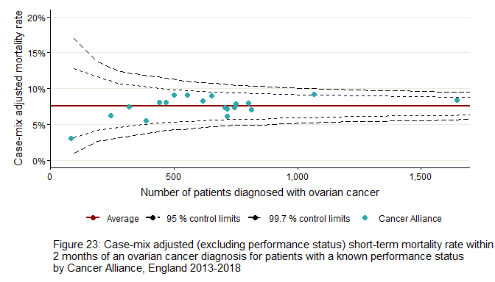
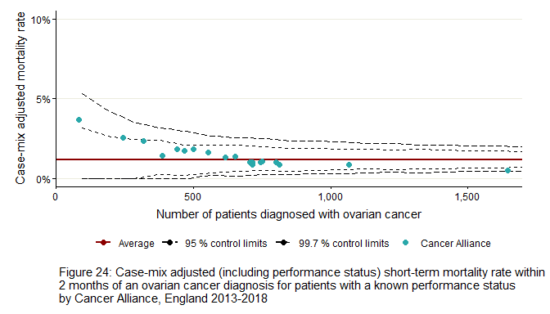

Appendix 10: Route to diagnosis by Cancer Alliance in patients with short-term mortality
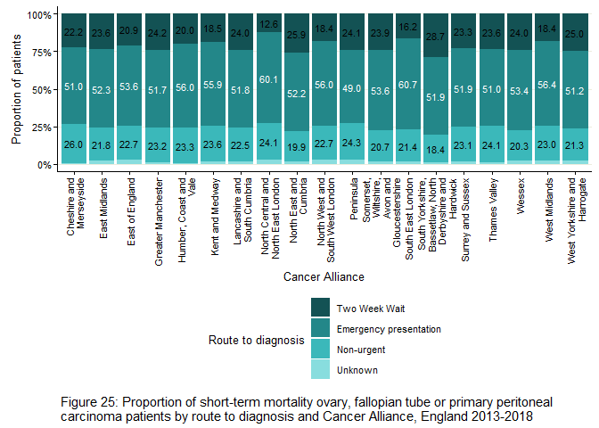

Appendix 11: Comorbidity conditions
Description | Charlson score | Notes
Acute myocardial infarction | 1
Congestive heart failure | 1
Peripheral vascular disease | 1
Cerebral vascular accident | 1
Dementia | 1
Pulmonary disease | 1
Connective tissue disorder | 1
Peptic ulcer | 1
Diabetes | 1 | Only highest score is counted
Diabetes complications | 2
Paraplegia | 2
Renal disease | 2
Cancer | 2 | Derived from cancer registry data rather than HES data.
Metastatic cancer | N/A
Liver disease | 1 | Only highest score is counted
Severe liver disease | 3
HIV | 6

Appendix 12: List of trusts containing specialist gynaecological cancer centres in 2021
Trust code | Trust name
RR7 | GATESHEAD HEALTH NHS FOUNDATION TRUST
RTR | SOUTH TEES HOSPITALS NHS FOUNDATION TRUST
RXN | LANCASHIRE TEACHING HOSPITALS NHS FOUNDATION TRUST
RWA | HULL UNIVERSITY TEACHING HOSPITALS NHS TRUST
RR8 | LEEDS TEACHING HOSPITALS NHS TRUST
REP | LIVERPOOL WOMEN'S NHS FOUNDATION TRUST
R0A | MANCHESTER UNIVERSITY NHS FOUNDATION TRUST
RHQ | SHEFFIELD TEACHING HOSPITALS NHS FOUNDATION TRUST
RL4 | ROYAL WOLVERHAMPTON NHS TRUST
RXK | SANDWELL & WEST BIRMINGHAM HOSPITALS NHS TRUST
RKB | UNIVERSITY HOSPITALS COVENTRY & WARWICKSHIRE NHS TRUST
RJE | UNIVERSITY HOSPITALS OF NORTH MIDLANDS NHS TRUST
RTG | UNIVERSITY HOSPITALS OF DERBY & BURTON NHS FOUNDATION TRUST
RNS | NORTHAMPTON GENERAL HOSPITAL NHS TRUST
RWE | UNIVERSITY HOSPITALS OF LEICESTER NHS TRUST
RX1 | NOTTINGHAM UNIVERSITY HOSPITALS NHS TRUST
RGT | CAMBRIDGE UNIVERSITY HOSPITALS NHS FOUNDATION TRUST
RDE | EAST SUFFOLK & NORTH ESSEX NHS FOUNDATION TRUST
RM1 | NORFOLK & NORWICH UNIVERSITY HOSPITALS NHS FOUNDATION TRUST
RAJ | SOUTHEND UNIVERSITY HOSPITAL NHS FOUNDATION TRUST
RWG | WEST HERTFORDSHIRE HOSPITALS NHS TRUST
R1H | BARTS HEALTH NHS TRUST
RJ1 | GUY'S & ST THOMAS' NHS FOUNDATION TRUST
RYJ | IMPERIAL COLLEGE HEALTHCARE NHS TRUST
RPY | ROYAL MARSDEN NHS FOUNDATION TRUST
RRV | UNIVERSITY COLLEGE LONDON HOSPITALS NHS FOUNDATION TRUST
RTE | GLOUCESTERSHIRE HOSPITALS NHS FOUNDATION TRUST
RBA | TAUNTON & SOMERSET NHS FOUNDATION TRUST
RA7 | UNIVERSITY HOSPITALS BRISTOL NHS FOUNDATION TRUST
RD1 | ROYAL UNITED HOSPITALS BATH NHS FOUNDATION TRUST
REF | ROYAL CORNWALL HOSPITALS NHS TRUST
RH8 | ROYAL DEVON & EXETER NHS FOUNDATION TRUST
RTH | OXFORD UNIVERSITY HOSPITALS NHS FOUNDATION TRUST
RD3 | POOLE HOSPITAL NHS FOUNDATION TRUST
RHU | PORTSMOUTH HOSPITALS NHS TRUST
RHM | UNIVERSITY HOSPITAL SOUTHAMPTON NHS FOUNDATION TRUST
RWF | MAIDSTONE & TUNBRIDGE WELLS NHS TRUST
RVV | EAST KENT HOSPITALS UNIVERSITY NHS FOUNDATION TRUST
RA2 | ROYAL SURREY COUNTY HOSPITAL NHS FOUNDATION TRUST
RXH | BRIGHTON & SUSSEX UNIVERSITY HOSPITALS NHS TRUST

Appendix 13: Glossary
Term | Acronym | Description
Borderline/non-Borderline |  | Borderline ovarian tumours are abnormal cells that form in the tissue covering the ovary. They are different to ovarian cancer because they do not grow into the supportive tissue of the ovary (the stroma). They tend to grow slowly and in a more controlled way than cancer cells. The main treatment for borderline tumours is surgery. Most women are cured and have no further problems. There is a small risk of the tumour coming back. Very rarely, the borderline tumour cells change into cancer cells.
Cancer Alliances | CA | The 19 Cancer Alliances in England bring together the key organisations in their regions to coordinate cancer care and to plan for and lead delivery of improved outcomes for patients locally.
Cancer centre/unit |  | Cancer units provide diagnostic services for their local populations and refer cases of suspected or confirmed ovarian cancer to their local gynaecological cancer centre. Cancer centres house specialist gynae oncology MDTs and provide diagnostic and treatment services for patients referred from local cancer units.
Cancer registry | NCRAS | The National Cancer Registration and Analysis Service (NCRAS) collects data on all cases of cancer that occur in people diagnosed in England. The data is used to support public health, healthcare and research.
Carcinoma |  | Category of types of cancer that develop from epithelial cells.
Case-mix adjusted |  | A case-mix adjusted rate takes into account differences between patient populations by providing estimates based on an average group of patients. This allows for rates to be compared across geographies or time periods.
Comorbidity |  | A disease or condition that someone has in addition to the health problem being studied or treated (i.e. cancer).
Crude mortality rate |  | Mortality rate derived directly from the counts of relevant patients and the size of the cohort. For example, the crude mortality rate of ovarian, fallopian tube and primary peritoneal carcinomas in 2017 is the number of women who died and such tumours diagnosed divided by the number of women included in the cohort.
Fallopian tube |  | Fallopian tubes carry eggs from the ovaries to the uterus. Serous carcinomas of the fallopian tube are considered to be the same disease entity as serous cancers of the ovary and primary peritoneal carcinoma, which is why cancers at all 3 sites are collected in this report.
FIGO stage | FIGO | System for staging of gynaecological cancers, published by the International Federation of Gynaecology and Obstetrics (FIGO).
ICD codes | ICD | International Classification of Diseases is a medical classification and coding list for the identification of diseases, signs and symptoms, abnormal findings, complaints, social circumstances and external causes of injury or diseases, as maintained by the World Health Organization (WHO). ICD-10 classifies cancers by site and behaviour (malignancy) and ICD-O classifies cancers by site, morphology and behaviour.
Malignant |  | Malignant tumours are considered to be cancer. Malignant means characterised by the tendency to become progressively worse. Often characterised by anaplasia, invasiveness and /or metastases.
Morphology |  | Morphology is the type of a tumour, as diagnosed by a pathologist looking at the shape of the cells through a microscope. The morphological type of a tumour can be important in understanding how to treat that tumour and what expected outcomes might be. The morphology categories include the main subtypes of epithelial ovarian cancers (serous, endometrioid, clear cell, mucinous and other epithelial), categories for cases where the pathology detail was unspecified or the site was unspecified in the data, and the separate category of sex code stromal and germ cell tumours.
Mortality |  | Cancer mortality is the number of deaths from cancer in a specific population within a specific period of time. It usually only includes deaths where cancer is mentioned as an underlying cause of death on death certificates. Cancer mortality rates are a standard measure of the frequency of deaths from cancer within a specific period of time relative to a fixed population size.
Multidisciplinary team | MDT | MDTs bring together experts in specific areas of medicine and care, and usually meet every week to discuss the diagnosis, treatment and care of individual cancer patients.
NHS trusts |  | NHS hospital trusts are organisational units within the National Health Service in England, providing secondary health services in a particular local area.
Performance status |  | Performance status is an attempt to quantify cancer patients' general well-being and activities of daily life. This is captured as a WHO (World Health Organization) score between 0 and 4.
Peritoneum |  | The peritoneum is the serous membrane forming the lining of the abdominal cavity.
Primary peritoneal carcinomas | C48 | Cancer of the epithelial cells in the peritoneum. Primary peritoneal carcinomas are considered to be the same disease entity as serous carcinomas of the ovarian or fallopian tube, which is why cancers at all 3 sites are collected in this report.
Routes to diagnosis | RtD | A route to diagnosis describes the pathway a patient took through the healthcare system, and the interactions the patient made with primary and/or secondary care before receiving a cancer diagnosis.
Stage |  | Stage describes the extent or severity of a person’s cancer. Diagnosis at an earlier stage leads to improved prognosis, treatments and outcomes in comparison with cancers diagnosed at a later stage.
World Health Organization | WHO | The World Health Organization directs and coordinates international health within the United Nations system. The WHO classification systems for cancer sites are used in the cancer registry

Appendix 14: Useful links
Ovarian Cancer Audit Feasibility Pilot homepage  Information about this project and links to outputs. | http://ncin.org.uk/ocafp
NCRAS gynae hub ovarian cancer resources  Reports, briefings and other resources on ovarian cancer from NCRAS | http://ncin.org.uk/cancer_type_and_topic_specific_work/cancer_type_specific_work/gynaecological_cancer/gynaecological_cancer_hub/resources/ovarian_cancer
CancerData  NCRAS hub for incidence and mortality data by geographies, Routes to Diagnosis and treatment data for cancers including ovary. | https://www.cancerdata.nhs.uk/incidence  https://www.cancerdata.nhs.uk/mortality  https://www.cancerdata.nhs.uk/routestodiagnosis  https://www.cancerdata.nhs.uk/treatments
CancerStats I  For N3 (NHS) connections only, requires signup. Incidence and mortality with greater geographical granularity than CancerData. | https://nww.cancerstats.nhs.uk/
CancerStats II  For N3 (NHS) connections only, requires signup. Select Audits > OCAFP for project outputs including data completeness report. | https://cancerstats.ndrs.nhs.uk/
Data Resource Profile: National Cancer Registration Dataset in England  Information about the registry dataset used for this report. | https://doi.org/10.1093/ije/dyz076
Get Data Out: Ovary, fallopian tube and primary peritoneal carcinomas  Routine data from NCRAS on small groups of ovarian cancer patients since 2013. Incidence, Routes to Diagnosis, treatment, survival. | https://www.cancerdata.nhs.uk/getdataout/ovary  https://www.cancerdata.nhs.uk/getdataout/data
Progress in cancer survival, mortality, and incidence in seven high-income countries 1995–2014 (ICBP SURVMARK-2): a population-based study, The Lancet Oncology, Arnold et al. 2019  International comparison of cancer incidence, mortality and survival, including ovarian cancer | https://doi.org/10.1016/S1470-2045(19)30456-5
Stage breakdown by CCG 2017  NCRAS stage data for sites including ovary, split by CCG. | http://www.ncin.org.uk/view?rid=3864

References
- National Cancer Registration and Analysis Service. Ovarian Cancer Audit Feasibility Pilot - Outputs [Internet]. 2020. Available from: http://ncin.org.uk/cancer_type_and_topic_specific_work/cancer_type_specific_work/gynaecological_cancer/gynaecological_cancer_hub/ovarian_cancer_audit_feasibility_pilot_outputs.
- NCIN data briefing: Short Term Ovarian Cancer Mortality [Internet]. 2013. Available from: http://ncin.org.uk/view?rid=2128.
- Barclay M, Gildea C, Poole J, Hirschowitz L, Menon U, Nordin A. Factors Affecting Short-term Mortality in Women With Ovarian, Tubal, or Primary Peritoneal Cancer: Population-Based Cohort Analysis of English National Cancer Registration Data, International Journal of Gynecological Cancer. 2016;26(1):56-65. Available from: doi:10.1097/IGC.0000000000000562.
- Association of Public Health Observatories. Technical Briefing 3: Commonly used public health statistics and their confidence intervals. York; 2008.
- National Cancer Registration and Analysis Service. Get Data Out: Ovarian Grouping. [Internet]. 2021. Available from: https://www.cancerdata.nhs.uk/getdataout/Ovarian_Grouping.docx.
- Muller P, Walters S, Coleman MP, Woods L. Which indicators of early cancer diagnosis from population-based data sources are associated with short-term mortality and survival?. Cancer Epidemiology. 2018;56:161-170. Available from: doi:10.1016/j.canep.2018.07.010.
- Swann R, McPhail S, Witt J, Shand B, Abel GA, Hiom S, et al. Diagnosing cancer in primary care: results from the National Cancer Diagnosis Audit. British Journal of General Practice. 2018;68(666):63-72. Available from: doi:10.3399/bjgp17X694169.
- Elliss-Brookes L, McPhail S, Ives A, Greenslade M, Shelton J, Hiom S et al. Routes to diagnosis for cancer - determining the patient journey using multiple routine data sets. British Journal of Cancer. 2012;107:1220-1226. Available from: doi:10.1038/bjc.2012.408.
- Herbert A, Abel GA, Winters S, McPhail S, Elliss-Brookes L, Lyratzopoulos G. Cancer diagnoses after emergency GP referral or A&E attendance in England: determinants and time trends in Routes to Diagnosis data, 2006-2015. British Journal of General Practice. 2019;69(687):724-730. Available from: doi:10.3399/bjgp19X705473.
- Woods LM, Rachet B, Coleman MP. Origins of socio-economic inequalities in cancer survival: a review. Annals of Oncology. 2006;17(1):5-19. Available from: doi:10.1093/annonc/mdj007.
- Sarfati D, Koczwara B, Jackson C. The impact of comorbidity on cancer and its treatment. CA: A Cancer Journal for Clinicians. 2016;66(4):337-350. Available from: doi:10.3322/caac.21342.
- Charlson ME, Pompei P, Ales KL, MacKenzie CR. A new method of classifying prognostic comorbidity in longitudinal studies: development and validation. Journal of Chronic Diseases. 1987;40(5):373-383. Available from: doi:10.1016/0021-9681(87)90171-8.
- Mendonca SC, Abel GA, Gildea C, McPhail S, Peake MD, Rubin G, et al. Associations between general practice characteristics with use of urgent referrals for suspected cancer and endoscopies: a cross-sectional ecological study. Family Practice. 2018;36(5):573–580. Available from: doi:10.1093/fampra/cmy118.
- McPhail S, Elliss-Brookes L, Shelton J, Ives A, Greenslade M, Vernon S, et al. Emergency presentation of cancer and short-term mortality. British Journal of Cancer. 2013;109:2027–2034. Available from: doi:10.1038/bjc.2013.569.
- Spiegelhalter DJ. Funnel plots for comparing institutional performance. Statistics in Medicine. 2005;24(8):1185-1202. Available from: doi:10.1002/sim.1970.
- Gilbert T, Neuburger J, Kraindler J, Keeble E, Smith P, Ariti C, at al. Development and validation of a Hospital Frailty Risk Score focusing on older people in acute care settings using electronic hospital records: an observational study. The Lancet. 2018;391(10135):1775-1782. Available from: doi:10.1016/S0140-6736(18)30668-8.
- Kang H. The prevention and handling of the missing data. Korean Journal of Anesthesiology. 2013;65(5):402-406. Available from: doi:10.4097/kjae.2013.64.5.402.
- Crooks CJ, West J, Card TR. A comparison of the recording of comorbidity in primary and secondary care by using the Charlson Index to predict short-term and long-term survival in a routine linked data cohort. BMJ Open. 2015;5(6). Available from: doi:10.1136/bmjopen-2015-007974.
- Fowler H, Belot A, Ellis L, Maringe C, Luque-Fernandez MA, Njagi EN, et al. Comorbidity prevalence among cancer patients: a population-based cohort study of four cancers. BMC Cancer. 2020;20(2). Available from: doi:10.1186/s12885-019-6472-9.
- Robinson WS. Ecological Correlations and the Behavior of Individuals. International Journal of Epidemiology. 2009;38(2):337–341. Available from: doi:10.1093/ije/dyn357.
- Henson KE, Elliss-Brookes L, Coupland VH, Payne E, Vernon S, Rous B, et al. Data Resource Profile: National Cancer Registration Dataset in England. International Journal of Epidemiology. 2020;49(1):16-16h. Available from: doi:10.1093/ije/dyz076.
- NHS. NHS Data Model and Dictionary: Basis of diagnosis for cancer [Internet]. 2021. Available from: https://datadictionary.nhs.uk/attributes/basis_of_diagnosis_for_cancer.html.
- ECOG-ACRIN Cancer Research Group. ECOG Performance Status [Internet]. Available from: https://ecog-acrin.org/resources/ecog-performance-status
- NHS Digital. GP and GP practice related data, GPs by GP Practices [Internet]. 2021. Available from: https://digital.nhs.uk/services/organisation-data-service/file-downloads/gp-and-gp-practice-related-data.
- NHS Digital. Patients Registered at a GP Practice [Internet]. 2020. Available from: https://digital.nhs.uk/data-and-information/publications/statistical/patients-registered-at-a-gp-practice.
- Cox DR, Snell EJ. Analysis of binary data (Vol. 32). CRC Press. 1989.
- R Core Team (2021) R: A language and environment for statistical computing. R Foundation for Statistical Computing, Vienna, Austria. Available from: https://www.R-project.org/.

